Real-Time Automated Cyber Threat Classification and Emerging Threat Detection Framework
ABSTRACT
Automating cyber threat intelligence (CTI) collection and analysis in real time is critical for the timely detection and mitigation of cyber threats. Cybersecurity researchers have recently recommended CTI as a proactive and robust method for automated cyber threat prediction. This automated solution collects and analyses real-time data from social media, cybersecurity forums, and hacker forums where cybersecurity analysts and hackers discuss cybersecurity-related topics to discover potential threats. In this article, we propose a comprehensive framework that automates both cyber threat classification and emerging threat detection using real-time data from surface, deep, and dark web sources. We collected real-time data from hackers and security forums to construct binary and multiclass cyber threat classifications. We employed a labelled leaked dataset to be considered as ground truth for classification. Machine and deep learning techniques were used to perform the classification. Latent Dirichlet allocation (LDA) and nonnegative matrix factorization (NMF) were used to analyse topic distribution over time and identify emerging threats. This approach allows for the identification of zero-day attacks and other emerging threats by monitoring shifts in topics. Using a support vector machine with the bag-of-words (binary term weight) model achieved the highest accuracies of 93.67 and 96.35 for binary and multiclass classifications, respectively. Moreover, LDA and NMF were used to extract the top topics from various numbers of topics. The LDA model is well suited for identifying emerging trends and useful for real-time threat monitoring in cybersecurity.
KEYWORDS
Cyber Threat Detection, Real-Time Data Collection, Machine Learning, Deep Learning, Natural Language Processing (NLP), Text Mining, Cyber Threat Intelligence (CTI), Topic Modeling, LDA, NMF, SVM, Random Forest, XGBoost, CNN, LSTM, Binary Classification, Multiclass Classification, Bag of Words (BoW), Threat Analysis, Zero-Day Attack Detection.

INTRODUCTION:
The rapid growth of digital technologies, online platforms, and interconnected systems has significantly increased the complexity and frequency of cyber threats. Attackers continuously develop new techniques, vulnerabilities, malware, and attack strategies, making traditional security approaches less effective against rapidly evolving threats. Cyber Threat Intelligence (CTI) has therefore become an important proactive approach for identifying, understanding, and responding to potential cyber threats. CTI involves collecting information from various sources and transforming it into meaningful intelligence that can support cybersecurity analysts in detecting threats before they cause significant damage.
Traditional CTI collection and analysis often depend heavily on manual monitoring and expert investigation, which can be time-consuming and difficult to perform continuously. Valuable information about emerging cyber threats is frequently discussed across social media platforms, cybersecurity communities, security forums, hacker forums, and different layers of the web. Surface, deep, and dark web sources can contain early indicators of attacks, vulnerabilities, leaked information, and discussions related to malicious activities. Automatically collecting and analysing such real-time information can help security teams identify important threat-related patterns more quickly and reduce the delay between threat discovery and response.
Machine learning and deep learning techniques provide effective methods for automatically processing large volumes of cyber-related data and identifying complex patterns within them. These techniques can be applied to classify collected information into different cyber threat categories, including both binary and multiclass classification problems. In addition to classification, analysing how cybersecurity topics change over time can provide valuable information about emerging threats. Topic modelling techniques such as Latent Dirichlet Allocation (LDA) and Nonnegative Matrix Factorization (NMF) can identify major topics within large collections of textual data and track changes in their distribution, helping analysts discover unusual or rapidly growing threat-related discussions.
Therefore, an automated real-time CTI framework can provide a comprehensive approach for both cyber threat classification and emerging threat detection. By combining real-time data collection from surface, deep, and dark web sources with machine learning, deep learning, and topic modelling techniques, the proposed approach can support proactive cybersecurity monitoring. Such a framework can assist in detecting known threats as well as identifying previously unseen or emerging threats, including potential zero-day attacks. The integration of automated classification with temporal topic analysis can consequently improve the speed, scalability, and effectiveness of cyber threat intelligence and provide cybersecurity analysts with timely information for threat detection and mitigation.
OBJECTIVE OF THE PROJECT:
- To automate Cyber Threat Intelligence (CTI) collection from real-time sources such as social media, cybersecurity forums, hacker forums, and different web environments.
- To classify cyber threats automatically using machine learning and deep learning techniques into binary and multiclass threat categories.
- To analyse cybersecurity topics and trends using topic modelling techniques such as LDA and NMF to understand the distribution of threat-related topics over time.
- To detect emerging and potential zero-day threats by identifying significant changes and new patterns in cybersecurity discussions.
- To provide timely and actionable threat intelligence that can help cybersecurity analysts improve threat detection, monitoring, and mitigation.
LITERATURE SURVEY:
“Real-Time Automated Cyber Threat Classification and Emerging Threat Detection Framework”
Alemayehu Tilahun Haile, Surafel Lemma Abebe, Henock Mulugeta Melaku (2025)
Automating cyber threat intelligence (CTI) collection and analysis in real time is critical for the timely detection and mitigation of cyber threats. Cybersecurity researchers have recently recommended CTI as a proactive and robust method for automated cyber threat prediction. This automated solution collects and analyzes real-time data from social media, cybersecurity forums, and hacker forums where cybersecurity analysts and hackers discuss cybersecurity-related topics to discover potential threats. In this article, we propose a comprehensive framework that automates both cyber threat classification and emerging threat detection using real-time data from surface, deep, and dark web sources. We collected real-time data from hackers and security forums to construct binary and multiclass cyber threat classifications. We employed a labeled leaked dataset to be considered as ground truth for classification. Machine and deep learning techniques were used to perform the classification. Latent Dirichlet allocation (LDA) and nonnegative matrix factorization (NMF) were used to analyze topic distribution over time and identify emerging threats. This approach allows for the identification of zero-day attacks and other emerging threats by monitoring shifts in topics. Using a support vector machine with the bag-of-words (binary term weight) model achieved the highest accuracies of 93.67 and 96.35 for binary and multiclass classifications, respectively. Moreover, LDA and NMF were used to extract the top topics from various numbers of topics. The LDA model is well suited for identifying emerging trends and useful for real-time threat monitoring in cybersecurity.
“Real-Time Cyber Threat Detection, Monitoring and reporting System”
Onkar Halge, Chaitanya Jadhav, Shubham Jadhav, Sudarshan Jadhav (2026)
The fast increase in cyber-attacks means we need better tools to spot and deal with threats quickly to stop big security problems. This study introduces a Real-Time Cyber Threat Monitoring and Reporting System that keeps checking for possible cyber dangers all the time. It uses data from public cybersecurity websites on the surface web, which is collected through web scraping. The system looks at text data, uses machine learning to find strange patterns and unusual behavior, and helps identify threats early. The system has a Python-based backend using Flask to handle data and run models, and a React.js frontend that gives a clear dashboard showing live alerts, summaries, and threat details. MongoDB is used to store and get large amounts of data quickly. By combining web data collection, natural language processing, and strong machine learning models, this system provides fast alerts and in-depth reports, helping cybersecurity experts take action before problems happen
“A Machine Learning Approach for the NLP-Based Analysis of Cyber Threats and Vulnerabilities of the Healthcare Ecosystem”
Stefano Silvestri, Shareee Isalam, Spyridon Papastergiou, Christos Tzagkarakis (2023)
Digitization in healthcare systems, with the wid adoption of Electronic Health Records, connected medical devices, software and systems providing efficient healthcare service delivery and management. On the other hand, the use of these systems has significantly increased cyber threats in the healthcare sector. Vulnerabilities in the existing and legacy systems are one of the key causes for the threats and related risks. Understanding and addressing the threats from the connected medical devices and other parts of the ICT health infrastructure are of paramount importance for ensuring security within the overall healthcare ecosystem. Threat and vulnerability analysis provides an effective way to lower the impact of risks relating to the existing vulnerabilities. However, this is a challenging task due to the availability of massive data which makes it difficult to identify potential patterns of security issues. This paper contributes towards an effective threats and vulnerabilities analysis by adopting Machine Learning models, such as the BERT neural language model and XGBoost, to extract updated information from the Natural Language documents largely available on the web, evaluating at the same time the level of the identified threats and vulnerabilities that can impact on the healthcare system, providing the required information for the most appropriate management of the risk. Experiments were performed based on CS news extracted from the Hacker News website and on Common Vulnerabilities and Exposures (CVE) vulnerability reports. The results demonstrate the effectiveness of the proposed approach, which provides a realistic manner to assess the threats and vulnerabilities from Natural Language texts, allowing adopting it in real-world Healthcare ecosystems.
“Latent dirichlet allocation”
David M. Blei, Andrew Y. Ng, Michel l. Jordan (2023)
We describe latent Dirichlet allocation (LDA), a generative probabilistic model for collections of discrete data such as text corpora. LDA is a three-level hierarchical Bayesian model, in which each item of a collection is modeled as a finite mixture over an underlying set of topics. Each topic is, in turn, modeled as an infinite mixture over an underlying set of topic probabilities. In the context of text modeling, the topic probabilities provide an explicit representation of a document. We present efficient approximate inference techniques based on variational methods and an EM algorithm for empirical Bayes parameter estimation. We report results in document modeling, text classification, and collaborative filtering, comparing to a mixture of unigrams model and the probabilistic LSI model.

“Hacker Forum Exploit and Classification for Proactive Cyber Threat Intelligence”
Apurv Singh Gautam, Yamini Gahlot, P. Kamat (2019)
The exponential growth in data and technology have brought in prospects for progressively destructive cyber-attacks. Traditional security controls are struggling to match with the intricacy of cybercriminal tools and methods, organizations are now looking for better approaches to strengthen their cyber security capabilities. Cyber Threat Intelligence (CTI) in real-time is one such proactive approach which ensures that deployed appliances, security solutions and strategies are continually evaluated or optimized. Amongst various platforms for threat intelligence, hacker forums deliver affluent metadata, and thousands of Tools, Techniques, and Procedures (TTP). This research paper employs machine learning and deep learning approach using neural networks to automatically classify hacker forum data into predefined categories and develop interactive visualizations that enables CTI practitioners to probe collected data for proactive and opportune CTI. The results from this research shows that among all the models, deep learning model RNN GRU gives the best classification results with 99.025% accuracy and 96.56% precision.
“Cyber-Threat Detection System Using a Hybrid Approach of Transfer Learning and Multi-Model Image Representation”
Farhan Ullah, Shamsher Ullah, Muhammad Rashid Naeem, Leonardo Mostarda, ungmin Rho (2022)
Currently, Android apps are easily targeted by malicious network traffic because of their constant network access. These threats have the potential to steal vital information and disrupt the commerce, social system, and banking markets. In this paper, we present a malware detection system based on word2vec-based transfer learning and multi-model image representation. The proposed method combines the textual and texture features of network traffic to leverage the advantages of both types. Initially, the transfer learning method is used to extract trained vocab from network traffic. Then, the malware-to-image algorithm visualizes network bytes for visual analysis of data traffic. Next, the texture features are extracted from malware images using a combination of scale-invariant feature transforms (SIFTs) and oriented fast and rotated brief transforms (ORBs). Moreover, a convolutional neural network (CNN) is designed to extract deep features from a set of trained vocab and texture features. Finally, an ensemble model is designed to classify and detect malware based on the combination of textual and texture features. The proposed method is tested using two standard datasets, CIC-AAGM2017 and CICMalDroid 2020, which comprise a total of 10.2K malware and 3.2K benign samples. Furthermore, an explainable AI experiment is performed to interpret the proposed approach.
“Collecting Cyber Threat Intelligence from Hacker Forums via a Two-Stage, Hybrid Process using Support Vector Machines and Latent Dirichlet Allocation”
Isuf Deliu, Carl Leichter, Katrin Franke (2018)
Traditional security controls, such as firewalls, anti-virus and IDS, are ill-equipped to help IT security and response teams keep pace with the rapid evolution of the cyber threat landscape. Cyber Threat Intelligence (CTI) can help remediate this problem by exploiting non-traditional information sources, such as hacker forums and "dark-web" social platforms. Security and response teams can use the collected intelligence to identify emerging threats. Unfortunately, when manual analysis is used to extract CTI from non-traditional sources, it is a time consuming, error-prone and resource intensive process. We address these issues by using a hybrid Machine Learning model that automatically searches through hacker forum posts, identifies the posts that are most relevant to cyber security and then clusters the relevant posts into estimations of the topics that the hackers are discussing. The first (identification) stage uses Support Vector Machines and the second (clustering) stage uses Latent Dirichlet Allocation. We tested our model, using data from an actual hacker forum, to automatically extract information about various threats such as leaked credentials, malicious proxy servers, malware that evades AV detection, etc. The results demonstrate our method is an effective means for quickly extracting relevant and actionable intelligence that can be integrated with traditional security controls to increase their effectiveness.
SYSTEM ANALYSIS
EXISTING SYSTEM
The existing cyber threat detection system relies on collecting real-time textual data from hacker forums, social media platforms, and cybersecurity discussion websites. After collecting the data, Natural Language Processing techniques are used to clean and preprocess the text. The processed data is converted into numerical vectors using the Bag of Words (BoW) encoding method. Various Machine Learning and Deep Learning algorithms such as Support Vector Machine (SVM), Random Forest, XGBoost, Naïve Bayes, CNN, and LSTM are trained to classify cyber threats into binary and multiclass categories. Topic modeling algorithms including Latent Dirichlet Allocation and Non-negative Matrix Factorization (NMF) are used to identify emerging cyber threat topics and monitor changing attack trends in real time.
DISADVANTAGES:
- Performance depends heavily on the quality of collected text data.
- Requires continuous data collection from multiple online sources.
- Deep learning models require high computational resources.
- Accuracy decreases when data contains noisy or misleading information.
- Topic modeling may not always detect newly evolving attack patterns accurately.
PROPOSED SYSTEM
The proposed system provides an automated framework for real-time cyber threat classification and emerging threat detection using Machine Learning and Deep Learning techniques. It continuously gathers cybersecurity-related text from public forums, hacker communities, and social platforms. After preprocessing with NLP techniques, the data is transformed using the Bag of Words encoding method for efficient feature representation. Multiple classification algorithms including SVM, Random Forest, XGBoost, CNN, Naïve Bayes, and LSTM are trained and evaluated for binary and multiclass threat prediction. LDA and NMF topic modeling methods analyse discussion trends to identify emerging cyber threats and possible zero-day attacks. The system enables accurate threat classification, continuous monitoring, and timely identification of new cyber-attack patterns without relying on manual analysis.
ADVANTAGES:
- Detects both binary and multiclass cyber threats.
- Uses real-time data for improved threat monitoring.
- Automatically identifies emerging cyber-attack trends.
- Reduces manual effort through intelligent automation.
- Supports early detection of zero-day attacks.

MODULE DESCRIPTION:
The proposed System can be divided into the following major modules:
1. Data Collection
Collects cybersecurity-related textual data from hacker forums, social media platforms, security blogs, and public threat intelligence sources in real time.
2. Data Preprocessing
Cleans and preprocesses collected text using NLP techniques such as tokenization, stop-word removal, punctuation removal, and stemming to improve data quality.
3. Feature Extraction
Converts cleaned text into numerical feature vectors using the Bag of Words (BoW) technique for machine learning model training.
4. Threat Classification
Trains and evaluates multiple Machine Learning and Deep Learning algorithms such as SVM, Random Forest, XGBoost, Naïve Bayes, CNN, and LSTM to classify threats into binary and multiclass categories.
5. Emerging Threat Detection
Applies LDA and NMF topic modeling algorithms to analyse discussion trends, identify emerging cyber threats, and detect possible zero-day attacks in real time.
6. Result Analysis
Displays classification results, performance metrics (Accuracy, Precision, Recall, F1-Score), and visualizes detected threat categories and trending cyber-attack topics.

SYSTEM ARCHITECTURE:
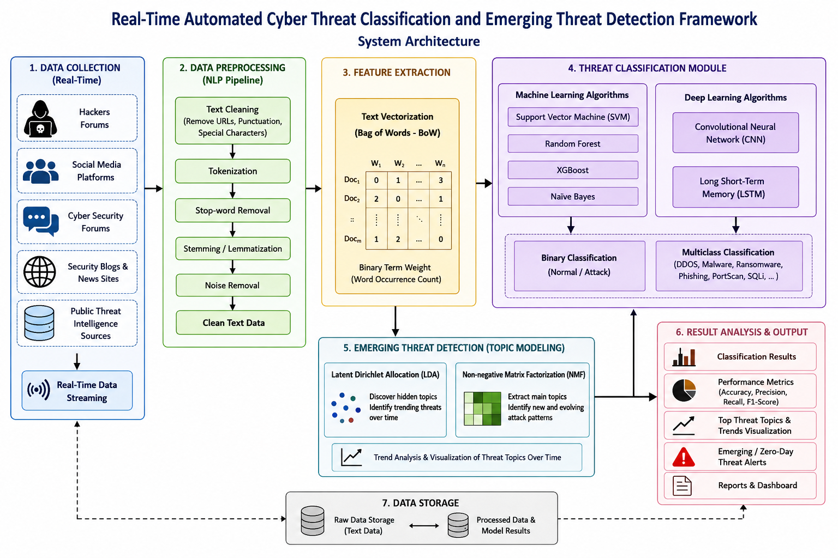

PROCESS MODEL USED WITH JUSTIFICATION
SDLC (Umbrella Model):
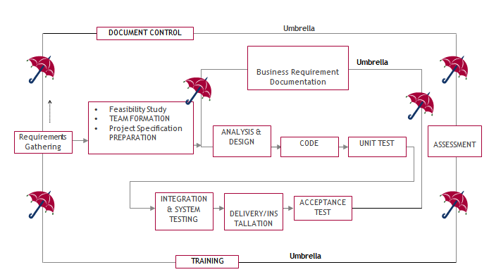
SDLC is nothing but Software Development Life Cycle. It is a standard which is used by software industry to develop good software.

Stages in SDLC:
- Requirement Gathering
- Analysis
- Designing
- Coding
- Testing
- Maintenance

Requirements Gathering stage:
The requirements gathering process takes as its input the goals identified in the high-level requirements section of the project plan. Each goal will be refined into a set of one or more requirements. These requirements define the major functions of the intended application, define operational data areas and reference data areas, and define the initial data entities. Major functions include critical processes to be managed, as well as mission critical inputs, outputs and reports. A user class hierarchy is developed and associated with these major functions, data areas, and data entities. Each of these definitions is termed a Requirement. Requirements are identified by unique requirement identifiers and, at minimum, contain a requirement title and textual description.
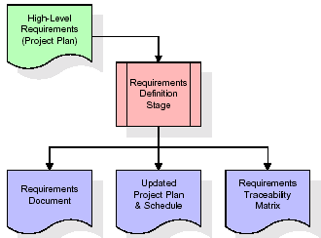
These requirements are fully described in the primary deliverables for this stage: the Requirements Document and the Requirements Traceability Matrix (RTM). The requirements document contains complete descriptions of each requirement, including diagrams and references to external documents as necessary. Note that detailed listings of database tables and fields are not included in the requirements document.
The title of each requirement is also placed into the first version of the RTM, along with the title of each goal from the project plan. The purpose of the RTM is to show that the product components developed during each stage of the software development lifecycle are formally connected to the components developed in prior stages.
In the requirements stage, the RTM consists of a list of high-level requirements, or goals, by title, with a listing of associated requirements for each goal, listed by requirement title. In this hierarchical listing, the RTM shows that each requirement developed during this stage is formally linked to a specific product goal. In this format, each requirement can be traced to a specific product goal, hence the term requirements traceability.
The outputs of the requirements definition stage include the requirements document, the RTM, and an updated project plan.
- Feasibility study is all about identification of problems in a project.
- No. of staff required to handle a project is represented as Team Formation, in this case only modules are individual tasks will be assigned to employees who are working for that project.
- Project Specifications are all about representing of various possible inputs submitting to the server and corresponding outputs along with reports maintained by administrator.

Analysis Stage:
The planning stage establishes a bird's eye view of the intended software product, and uses this to establish the basic project structure, evaluate feasibility and risks associated with the project, and describe appropriate management and technical approaches.
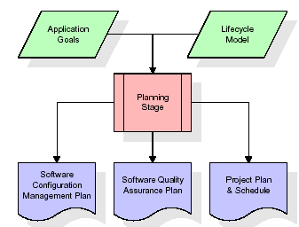
The most critical section of the project plan is a listing of high-level product requirements, also referred to as goals. All of the software product requirements to be developed during the requirements definition stage flow from one or more of these goals. The minimum information for each goal consists of a title and textual description, although additional information and references to external documents may be included. The outputs of the project planning stage are the configuration management plan, the quality assurance plan, and the project plan and schedule, with a detailed listing of scheduled activities for the upcoming Requirements stage, and high level estimates of effort for the out stages.

Designing Stage:
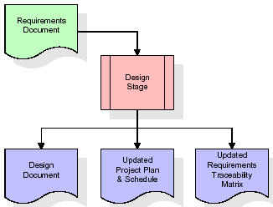
The design stage takes as its initial input the requirements identified in the approved requirements document. For each requirement, a set of one or more design elements will be produced as a result of interviews, workshops, and/or prototype efforts. Design elements describe the desired software features in detail, and generally include functional hierarchy diagrams, screen layout diagrams, tables of business rules, business process diagrams, pseudo code, and a complete entity-relationship diagram with a full data dictionary. These design elements are intended to describe the software in sufficient detail that skilled programmers may develop the software with minimal additional input.
When the design document is finalized and accepted, the RTM is updated to show that each design element is formally associated with a specific requirement. The outputs of the design stage are the design document, an updated RTM, and an updated project plan.
Development (Coding) Stage:
The development stage takes as its primary input the design elements described in the approved design document. For each design element, a set of one or more software artifacts will be produced. Software artifacts include but are not limited to menus, dialogs, and data management forms, data reporting formats, and specialized procedures and functions. Appropriate test cases will be developed for each set of functionally related software artifacts, and an online help system will be developed to guide users in their interactions with the software.
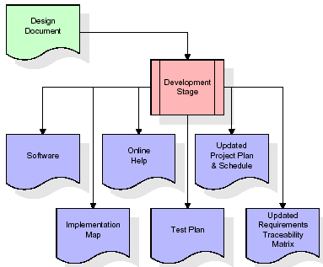

The RTM will be updated to show that each developed artifact is linked to a specific design element, and that each developed artifact has one or more corresponding test case items. At this point, the RTM is in its final configuration. The outputs of the development stage include a fully functional set of software that satisfies the requirements and design elements previously documented, an online help system that describes the operation of the software, an implementation map that identifies the primary code entry points for all major system functions, a test plan that describes the test cases to be used to validate the correctness and completeness of the software, an updated RTM, and an updated project plan.

Integration & Test Stage:
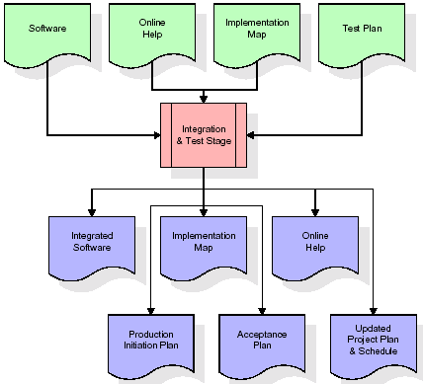
During the integration and test stage, the software artifacts, online help, and test data are migrated from the development environment to a separate test environment. At this point, all test cases are run to verify the correctness and completeness of the software. Successful execution of the test suite confirms a robust and complete migration capability. During this stage, reference data is finalized for production use and production users are identified and linked to their appropriate roles. The final reference data (or links to reference data source files) and production user list are compiled into the Production Initiation Plan.
The outputs of the integration and test stage include an integrated set of software, an online help system, an implementation map, a production initiation plan that describes reference data and production users, an acceptance plan which contains the final suite of test cases, and an updated project plan.

- Installation & Acceptance Test:
During the installation and acceptance stage, the software artifacts, online help, and initial production data are loaded onto the production server. At this point, all test cases are run to verify the correctness and completeness of the software. Successful execution of the test suite is a prerequisite to acceptance of the software by the customer.
After customer personnel have verified that the initial production data load is correct and the test suite has been executed with satisfactory results, the customer formally accepts the delivery of the software.
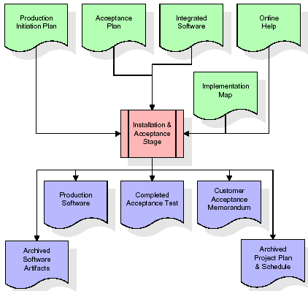
The primary outputs of the installation and acceptance stage include a production application, a completed acceptance test suite, and a memorandum of customer acceptance of the software. Finally, the PDR enters the last of the actual labor data into the project schedule and locks the project as a permanent project record. At this point the PDR "locks" the project by archiving all software items, the implementation map, the source code, and the documentation for future reference.

Maintenance:
Outer rectangle represents maintenance of a project, Maintenance team will start with requirement study, understanding of documentation later employees will be assigned work and they will undergo training on that particular assigned category. For this life cycle there is no end, it will be continued so on like an umbrella (no ending point to umbrella sticks).
SOFTWARE REQUIREMENT SPECIFICATION
Overall Description
A Software Requirements Specification (SRS) – a requirements specification for a software system is a complete description of the behaviour of a system to be developed. It includes a set of use cases that describe all the interactions the users will have with the software. In addition to use cases, the SRS also contains non-functional requirements. Non-functional requirements are requirements which impose constraints on the design or implementation (such as performance engineering requirements, quality standards, or design constraints).
System requirements specification: A structured collection of information that embodies the requirements of a system. A business analyst, sometimes titled system analyst, is responsible for analysing the business needs of their clients and stakeholders to help identify business problems and propose solutions. Within the systems development lifecycle domain, the BA typically performs a liaison function between the business side of an enterprise and the information technology department or external service providers. Projects are subject to three sorts of requirements:
- Business requirements describe in business terms what must be delivered or accomplished to provide value.
- Product requirements describe properties of a system or product (which could be one of several ways to accomplish a set of business requirements.)
- Process requirements describe activities performed by the developing organization. For instance, process requirements could specify .Preliminary investigation examine project feasibility, the likelihood the system will be useful to the organization. The main objective of the feasibility study is to test the Technical, Operational and Economical feasibility for adding new modules and debugging old running system. All system is feasible if they are unlimited resources and infinite time. There are aspects in the feasibility study portion of the preliminary investigation:
- ECONOMIC FEASIBILITY
A system can be developed technically and that will be used if installed must still be a good investment for the organization. In the economic feasibility, the development cost in creating the system is evaluated against the ultimate benefit derived from the new systems. Financial benefits must equal or exceed the costs. The system is economically feasible. It does not require any addition hardware or software. Since the interface for this system is developed using the existing resources and technologies available at NIC, there is nominal expenditure and economical feasibility for certain.
- OPERATIONAL FEASIBILITY
Proposed projects are beneficial only if they can be turned out into information system. That will meet the organization’s operating requirements. Operational feasibility aspects of the project are to be taken as an important part of the project implementation. This system is targeted to be in accordance with the above-mentioned issues. Beforehand, the management issues and user requirements have been taken into consideration. So there is no question of resistance from the users that can undermine the possible application benefits. The well-planned design would ensure the optimal utilization of the computer resources and would help in the improvement of performance status.
- TECHNICAL FEASIBILITY
Earlier no system existed to cater to the needs of ‘Secure Infrastructure Implementation System’. The current system developed is technically feasible. It is a web-based user interface for audit workflow at NIC-CSD. Thus, it provides an easy access to. the users. The database’s purpose is to create, establish and maintain a workflow among various entities in order to facilitate all concerned users in their various capacities or roles. Permission to the users would be granted based on the roles specified. Therefore, it provides the technical guarantee of accuracy, reliability and security.

EXTERNAL INTERFACE REQUIREMENTS
User Interface
The user interface of this system is a user-friendly python Graphical User Interface.
Hardware Interfaces
The interaction between the user and the console is achieved through python capabilities.

Software Interfaces
The required software is python.
SYSTEM REQUIREMENT:
HARDWARE REQUIREMENTS:
- Processor - Intel I3(min)
- Speed - 1.1 GHz
- RAM - 4GB(min)
- Hard Disk - 500GB(min)
SOFTWARE REQUIREMENTS:
- Operating System - Windows 10/above
- Programming Language - Python

SYSTEM DESIGN
UML Diagram:
The Unified Modelling Language allows the software engineer to express an analysis model using the modelling notation that is governed by a set of syntactic semantic and pragmatic rules.
A UML system is represented using five different views that describe the system from distinctly different perspective. Each view is defined by a set of diagram, which is as follows.
  - User Model View
    - This view represents the system from the users perspective.
    - The analysis representation describes a usage scenario from the end-users perspective.
  - Structural Model view
    - In this model the data and functionality are arrived from inside the system.
    - This model view models the static structures.
- Behavioural Model View
It represents the dynamic of behavioural as parts of the system, depicting the interactions of collection between various structural elements described in the user model and structural model view.

- Implementation Model View
In this the structural and behavioural as parts of the system are represented as they are to be built.
- Environmental Model View
In this the structural and behavioural aspects of the environment in which the system is to be implemented are represented.
Class Diagram:
The class diagram is the main building block of object orientedmodeling. It is used both for general conceptual modeling of the systematic of the application, and for detailed modeling translating the models into programming code. Class diagrams can also be used for data modeling. The classes in a class diagram represent both the main objects, interactions in the application and the classes to be programmed. In the diagram, classes are represented with boxes which contain three parts:
- The upper part holds the name of the class
- The middle part contains the attributes of the class
- The bottom part gives the methods or operations the class can take or undertake.
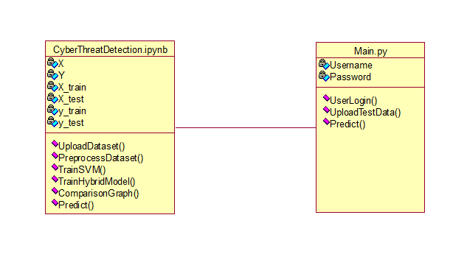
Use case Diagram:
A use case diagram at its simplest is a representation of a user's interaction with the system and depicting the specifications of a use case. A use case diagram can portray the different types of users of a system and the various ways that they interact with the system. This type of diagram is typically used in conjunction with the textual use case and will often be accompanied by other types of diagrams as well.

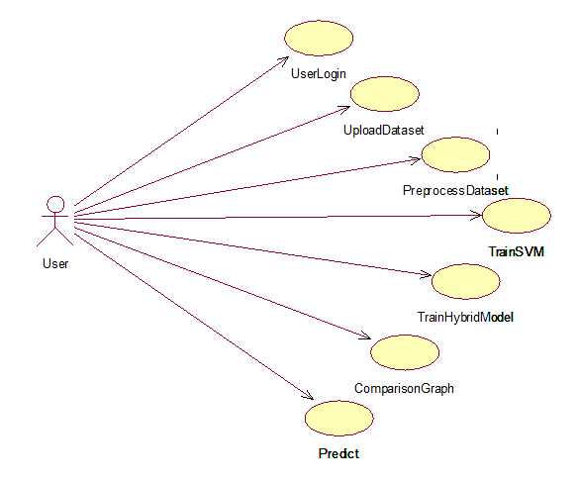

Sequence diagram:
A sequence diagram is a kind of interaction diagram that shows how processes operate with one another and in what order. It is a construct of a Message Sequence Chart. A sequence diagram shows object interactions arranged in time sequence. It depicts the objects and classes involved in the scenario and the sequence of messages exchanged between the objects needed to carry out the functionality of the scenario. Sequence diagrams are typically associated with use case realizations in the Logical View of the system under development. Sequence diagrams are sometimes called event diagrams, event scenarios, and timing diagrams.
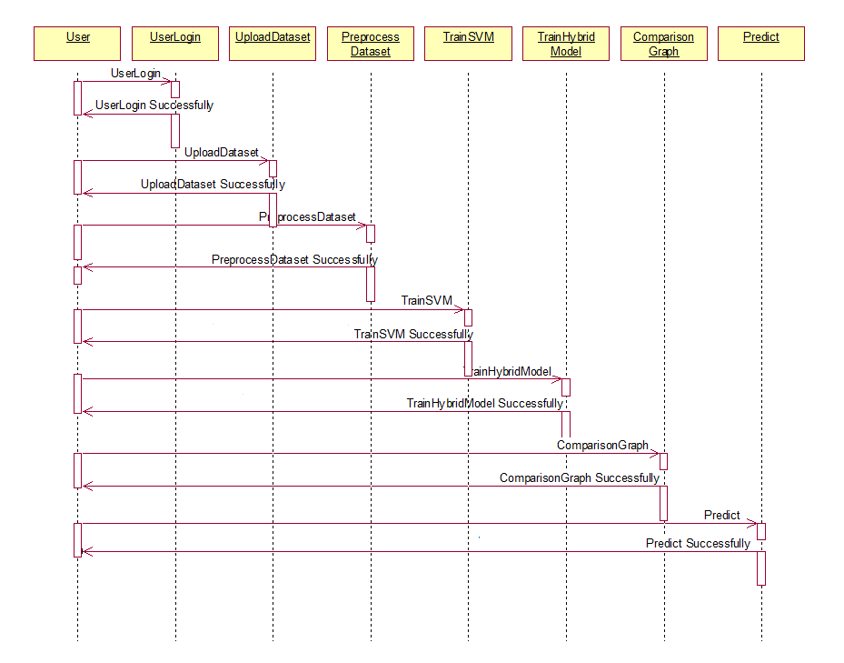

Collaboration diagram:
A collaboration diagram describes interactions among objects in terms of sequenced messages. Collaboration diagrams represent a combination of information taken from class, sequence, and use case diagrams describing both the static structure and dynamic behaviour of a system.

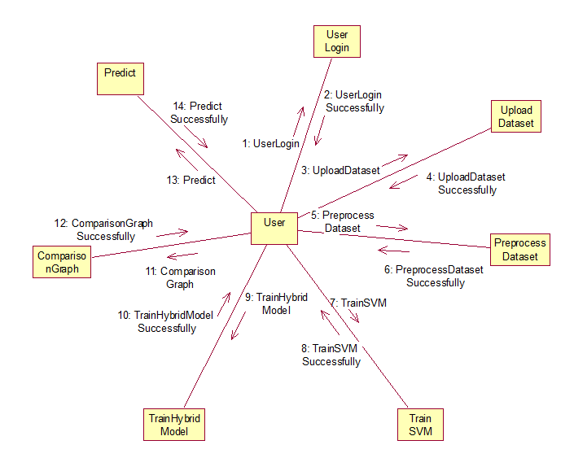

Component Diagram:
In the Unified Modelling Language, a component diagram depicts how components are wired together to form larger components and or software systems. They are used to illustrate the structure of arbitrarily complex systems.Components are wired together by using an assembly connector to connect the required interface of one component with the provided interface of another component. This illustrates the service consumer - service provider relationship between the two components.

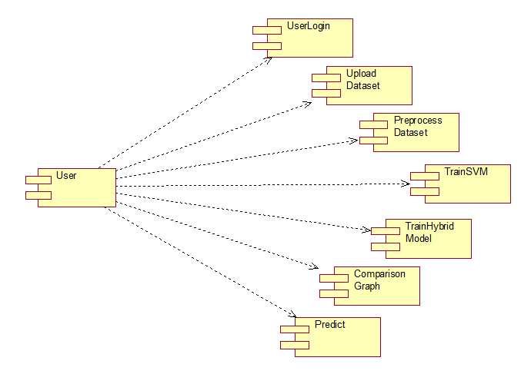

Deployment Diagram:
A deployment diagram in the Unified Modeling Language models the physical deployment of artifacts on nodes. To describe a web site, for example, a deployment diagram would show what hardware components ("nodes") exist (e.g., a web server, an application server, and a database server), what software components ("artifacts") run on each node (e.g., web application, database), and how the different pieces are connected (e.g. JDBC, REST, RMI).
The nodes appear as boxes, and the artifacts allocated to each node appear as rectangles within the boxes. Nodes may have sub nodes, which appear as nested boxes. A single node in a deployment diagram may conceptually represent multiple physical nodes, such as a cluster of database servers.
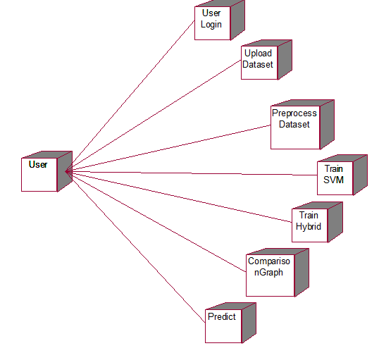

Activity Diagram:
Activity diagram is another important diagram in UML to describe dynamic aspects of the system. It is basically a flow chart to represent the flow form one activity to another activity. The activity can be described as an operation of the system. So the control flow is drawn from one operation to another. This flow can be sequential, branched or concurrent .
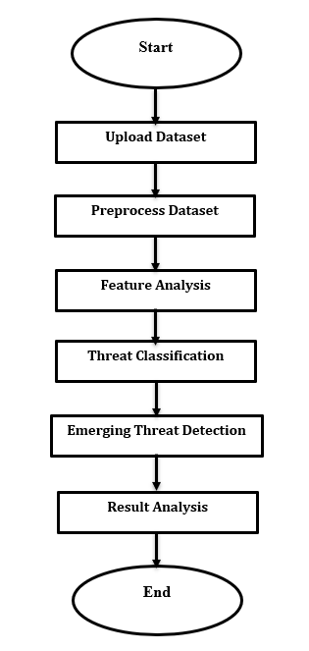
Data Flow Diagram:
Data flow diagrams illustrate how data is processed by a system in terms of inputs and outputs. Data flow diagrams can be used to provide a clear representation of any business function. The technique starts with an overall picture of the business and continues by analyzing each of the functional areas of interest. This analysis can be carried out in precisely the level of detail required.
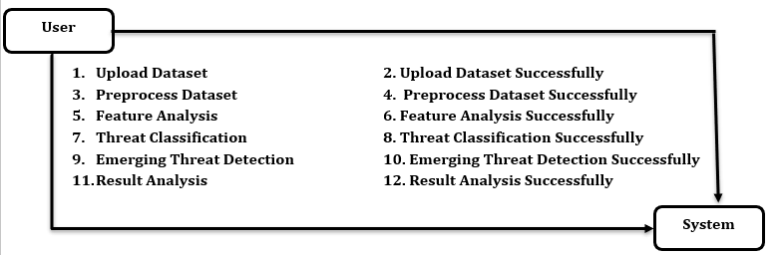

The technique exploits a method called top-down expansion to conduct the analysis in a targeted way.As the name suggests, Data Flow Diagram (DFD) is an illustration that explicates the passage of information in a process. A DFD can be easily drawn using simple symbols. Additionally, complicated processes can be easily automated by creating DFDs using easy-to-use, free downloadable diagramming tools. A DFD is a model for constructing and analyzing information processes. DFD illustrates the flow of information in a process depending upon the inputs and outputs. A DFD can also be referred to as a Process Model. A DFD demonstrates business or technical process with the support of the outside data saved, plus the data flowing from the process to another and the end results.

IMPLEMETATION
PYTHON
* One of the most popular languages is Python. Guido van Rossum released this language in 1991. Python is available on the Mac, Windows, and Raspberry Pi operating systems. The syntax of Python is simple and identical to that of English. When compared to Python, it was seen that the other language requires a few extra lines.
*It is an interpreter-based language because code may be run line by line after it has been written. This implies that rapid prototyping is possible across all platforms. Python is a big language with a free, binary-distributed interpreter standard library.
* It is inferior to maintenance that is conducted and is straightforward to learn. It is an object-oriented, interpreted programming language. It supports several different programming paradigms in addition to object-oriented programming, including functional and procedural programming.
* It supports several different programming paradigms in addition to object-oriented programming, including practical and procedural programming. Python is mighty while maintaining a relatively straightforward syntax. Classes, highly dynamic data types, modules, and exceptions are covered. Python can also be utilised by programmes that require programmable interfaces as an external language.
Here are some key features and characteristics of Python:
- Readability: Python emphasizes code readability with its clean and intuitive syntax. It uses indentation and whitespace to structure code blocks, making it easy to understand and maintain.
- Easy to Learn: Python's simplicity and readability make it an excellent choice for beginners. Its straightforward syntax and extensive documentation make it accessible for newcomers to programming.
- Interpreted Language: Python is an interpreted language, meaning that it doesn't need to be compiled before running. The Python interpreter reads and executes the code directly, making the development process faster and more interactive.
- Cross-platform Compatibility: Python is available for major operating systems like Windows, macOS, and Linux. This cross-platform compatibility allows developers to write code once and run it on different platforms without modifications.
- Large Standard Library: Python comes with a vast standard library that provides ready-to-use modules and functions for various tasks. It covers areas such as file I/O, networking, regular expressions, databases, and more, saving developers time and effort.
- Extensible and Modular: Python supports modular programming, enabling developers to organize code into reusable modules and packages. Additionally, Python allows integrating modules written in other languages, such as C or C++, providing flexibility and performance optimizations.
- Wide Range of Libraries and Frameworks: Python has a vibrant ecosystem with numerous third-party libraries and frameworks. These libraries, such as NumPy, pandas, TensorFlow, and Django, extend Python's capabilities for specific domains, making it a powerful tool for diverse applications.
- Object-Oriented: Python supports object-oriented programming (OOP) principles, allowing developers to create and work with classes and objects. OOP provides a structured approach to code organization, promoting code reuse and modularity.
- Dynamic Typing: Python is dynamically typed, meaning variable types are determined at runtime. Developers do not need to declare variable types explicitly, which enhances flexibility and simplifies code writing.
Installation
To install Python on your computer, follow these basic steps:
- Step 1: Visit the Python website Go to the official Python website at https://www.python.org/.
- Step 2: Select the operating system Choose the appropriate installer for your operating system. Python supports Windows, macOS, and various Linux distributions. Make sure to select the correct version that matches your operating system.
- Step 3: Check which version of Python is installed; if the 3.7.0 version is not there, uninstall it through the control panel and
- Step 4: Install Python 3.7.0 using Cmd.
- Step 5: Install the all libraries that required to run the project
- Step 6: Run
Python Features:
- Easy: Because Python is a more accessible and straightforward language, Python programming is easier to learn.
- Interpreted language: Python is an interpreted language;therefore it can be used to examine the code line by line and provide results.
- Open Source: Python is a free online programming language since it is open-source.
- Portable: Python is portable because the same code may be used on several computer standard
- libraries: Python offers a sizable library that we may utilize to create applications quickly.
- GUI: It stands for GUI (Graphical User Interface)
- Dynamical typed: Python is a dynamically typed language; therefore the type of the value will be determined at runtime.
Python IDLE
- Python IDLE offers a full-fledged file editor, which gives you the ability to write and execute Python programs from within this program. The built-in file editor also includes several features, like code completion and automatic indentation, that will speed up your coding workflow.
- Guido Van Rossum named Python after the British comedy group Monty Python while the name IDLE was chosen to pay tribute to Eric Idle, who was one of the Monty Python's founding members. IDLE comes bundled with the default implementation of the Python language since the 01.5. 2b1 release
- IDLE is used to execute statements similar to Python Shell. IDLE is used to create, modify, and execute Python code. IDLE provides a fully-featured text editor to write Python scripts and provides features like syntax highlighting, auto-completion, and smart indent.
- IDLE has two modes: interactive and script. We wrote our first program, “Hello, World!” in interactive mode. Interactive mode immediately returns the results of commands you enter into the shell. In script mode, you will write a script and then run it.
- The IDE Python IDLE is a good place to start as it helps you become familiar with the way Python works and understand its syntax. This IDE is good to start programming in Python due to its great debugger, but once you are fluent and start developing projects it is necessary to jump to another, more complete IDE.
- Python IDLE (Integrated Development and Learning Environment) is an interactive development environment included with the Python programming language. It provides a convenient way to write, execute, and debug Python code.
When you install Python, IDLE is typically installed along with it. To open IDLE, you can follow these steps:
- Open the command prompt (Windows) or terminal (macOS/Linux).
- Type "idle" and press Enter. Alternatively, you can specify the version with "idle3" or "idle2" for Python 3 or Python 2, respectively.
- Once IDLE is launched, you will see the Python shell, which is an interactive environment where you can type and execute Python code directly.
Here are some features and functionalities provided by Python IDLE:
- Editor: IDLE includes a text editor where you can write your Python code. It offers syntax highlighting, automatic indentation, and code completion to enhance your coding experience.
- Interactive Shell: The Python shell in IDLE allows you to execute Python code interactively. You can type commands, statements, or function calls directly in the shell, and Python will execute them immediately.
- Debugging: IDLE provides basic debugging capabilities to help you find and fix errors in your code. You can set breakpoints, step through code, inspect variables, and track the program's execution.
- Python Help: IDLE provides access to the Python documentation and built-in help. You can access the help menu to find information about Python modules, functions, classes, and more.
- Script Execution: In addition to the interactive shell, IDLE allows you to run Python scripts stored in files. You can write your code in the editor and execute it as a script to see the output or interact with the program.
- Customization: IDLE can be customized to suit your preferences. You can modify settings related to syntax highlighting, indentation, fonts, and more.
- Python IDLE serves as a beginner-friendly development environment and learning tool. It is suitable for writing small scripts, testing code snippets, experimenting with Python features, and learning the language's basics. However, for more advanced development projects, you may consider using other code editors or integrated development environments (IDEs) that provide additional features and better project management capabilities.

LIBRARIES :
In Python, libraries (also referred to as modules or packages) are collections of pre-written code that provide additional functionality and tools to extend the capabilities of the Python language. Libraries contain reusable code that developers can leverage to perform specific tasks without having to write everything from scratch.
Python libraries are designed to solve common problems, such as handling data, performing mathematical operations, interacting with databases, working with files, implementing networking protocols, creating graphical user interfaces (GUIs), and much more. They provide ready-to-use functions, classes, and methods that simplify complex operations and save development time.

Libraries in Python offer various advantages:
- Code Reusability
- Efficiency
- Collaboration
- Domain-Specific Functionality
- To use a Python library, you need to install it first.
There are some libraries following:

- Flask:
Flask is a lightweight and flexible web framework for Python that allows developers to build web applications quickly and efficiently. It follows a minimalistic approach, giving developers the freedom to structure their applications as needed while providing essential tools for routing, templating, and handling HTTP requests. In the context of this project, Flask is used to deploy the hotel booking cancellation prediction model as a web application. It enables users to interact with the model through a browser interface, upload test datasets, and receive real-time predictions for whether a booking will be cancelled or not. Flask also supports integration with front-end templates, making it possible to create user-friendly web pages for login, file upload, and result visualization, thereby bridging the gap between machine learning models and end-user applications.
Key Features of Flask:
- Lightweight and Flexible – Provides core functionality for routing, request handling, and templating while allowing developers to add only the components they need.
- Routing and URL Handling – Easily maps URLs to Python functions, enabling dynamic web pages and API endpoints.
- Template Engine (Jinja2) – Supports dynamic HTML rendering with variables, loops, and conditional statements for displaying model results interactively.
- Integration with Python Libraries – Seamlessly works with Python’s machine learning, data processing, and visualization libraries, such as Pandas, NumPy, and Matplotlib, making it ideal for ML-powered web apps.
- Lightweight Server for Development – Comes with a built-in development server, allowing easy testing and debugging before deployment.
- Scalable for Production – Can be integrated with production servers like Gunicorn or deployed on cloud platforms to handle larger user traffic.

- NLTK
The Natural Language Toolkit (NLTK) is a widely used open-source Python library designed to help developers and researchers work with human language data. It provides a rich collection of tools for tasks such as tokenization, stemming, lemmatization, part-of-speech tagging, and syntactic parsing, making it especially valuable for beginners learning the fundamentals of Natural Language Processing. NLTK includes numerous built-in corpora and lexical resources, such as the Gutenberg collection, WordNet, and movie review datasets, allowing users to experiment with real-world text without the need to gather data manually. Its modular structure and simple API make common preprocessing tasks easy to implement, whether someone is cleaning text, identifying sentence boundaries, or extracting keywords. Although NLTK is not optimized for high-performance production systems, it remains one of the most powerful educational tools for understanding traditional NLP methods. It is often used in academic courses, research experiments, and rapid prototyping before transitioning to more modern libraries like spaCy or transformer-based frameworks. Overall, NLTK plays an essential role in introducing core concepts of computational linguistics while giving users the flexibility to explore and experiment with different language processing techniques.
Key Features of NLTK
- Tokenization – Splits text into words or sentences for further processing.
- Stop word Removal – Provides lists of common words to filter out noise in text.
- Stemming – Reduces words to their root forms (e.g., “running” → “run”).
- Lemmatization – Converts words to their meaningful base forms using vocabulary and rules.
- Part-of-Speech Tagging (POS Tagging) – Assigns grammatical tags like noun, verb, adjective, etc.
- NumPy:
The NumPy Python library for multi-dimensional, big-scale matrices adds a huge number of high-level mathematical functions. It is possible to modify NumPy by utilizing a Python library. Along with line, algebra, and the Fourier transform operations, it also contains several matrices-related functions.
NumPy can be used to perform a wide variety of mathematical operations on arrays. It adds powerful data structures to Python that guarantee efficient calculations with arrays and matrices and it supplies an enormous library of high-level mathematical functions that operate on these arrays and matrices.
- NumPy is a Python library used for working with arrays.
- It also has functions for working in domain of linear algebra, Fourier transform, and matrices.
- NumPy was created in 2005 by Travis Oliphant. It is an open source project and you can use it freely.
- NumPy stands for Numerical Python.
- In Python we have lists that serve the purpose of arrays, but they are slow to process.
- NumPy aims to provide an array object that is up to 50x faster than traditional Python lists.
- The array object in NumPy is called ndarray, it provides a lot of supporting functions that make working with ndarray very easy.
- Arrays are very frequently used in data science, where speed and resources are very important.

- Matplotlib:
It is a multi-platform, array-based data visualization framework built to interact with the whole SciPy stack. MATLAB is proposed as an open-source alternative. Matplotlib is a Python extension and a cross-platform toolkit for graphical plotting and visualization.
Matplotlib is a popular Python library for creating static, animated, and interactive visualizations. It provides a flexible and comprehensive set of tools for generating plots, charts, histograms, scatter plots, and more. Matplotlib is widely used in various fields, including data analysis, scientific research, and data visualization.
Here are some key features and functionalities of the Matplotlib library:
- Plotting Functions
- Customization Options
- Multiple Interfaces
- Integration with NumPy and pandas
- Subplots and Figures:
- Saving and Exporting

- Pandas:
Pandas is a Python module utilized for analyzing data and manipulation. It provides a distinct operation along with data format for managing time series as well as numerical tables. It significantly diverges away from the release3-clause found in the BSD license. It is a popular open-source tool used in machine learning and data analysis.
Pandas is a Python library that offers efficient, versatile, & expressive data structures aimed at facilitating the manipulation of "relational" or "labeled" data in a straightforward and natural manner. It aspires to serve as the essential high-level framework for doing realistic, practical analysis of information in Python. Pandas is a Python package used for data set manipulation.
- It has capabilities for analyzing, cleansing, exploring, and modifying data.
- The term "Pandas" alludes to both "Panel Data" and "Python Data Analysis," and was developed by Wes McKinney around 2008.
- Pandas enables the analysis of large datasets and facilitates conclusions derived from statistical principles.
- Pandas can sanitize disordered data sets, making them comprehensible and relevant.
- Sklearn:
Scikit-learn, often imported as sklearn, is one of the most widely used open-source Python libraries for machine learning and data analysis. It provides a comprehensive set of tools for classification, regression, clustering, dimensionality reduction, preprocessing, and model evaluation. Built on top of foundational libraries like NumPy, SciPy, and matplotlib, Scikit-learn ensures efficient handling of large datasets and seamless integration with other Python-based data science tools.
Key Features of Scikit-learn:
- Supervised and Unsupervised Learning: Supports algorithms such as Support Vector Machine (SVM), Random Forest, Decision Tree, Naive Bayes, K-Means, and PCA.
- Preprocessing and Feature Engineering: Includes utilities for scaling, normalization, encoding categorical variables, and feature extraction to prepare data for model training.
- Model Selection and Evaluation: Provides tools for splitting datasets, cross-validation, and hyperparameter tuning using GridSearchCV and RandomizedSearchCV.
- Performance Metrics: Offers multiple evaluation metrics such as accuracy, precision, recall, F1-score, ROC curve, and confusion matrix to measure the efficiency of models.
- Pipeline Support: Allows the combination of multiple steps (like preprocessing and training) into a single pipeline, making workflows more efficient and reproducible.
- Extensibility: Can be easily integrated with other deep learning frameworks (like Keras or TensorFlow) to create hybrid AI systems.

ALGORITHM:

1. Random Forest
Random Forest is an ensemble machine learning algorithm that combines the predictions of multiple decision trees to perform classification. Each tree is trained using different subsets of the available training data and features, allowing the model to learn diverse patterns from the dataset. In this cyber threat detection project, Random Forest is used for multiclass classification of cyber threat text. The algorithm analyzes the numerical features generated from the processed text data and predicts the corresponding threat category. Its ensemble structure helps reduce the limitations of using a single decision tree and provides stable classification results. The performance of Random Forest is evaluated using accuracy, precision, recall, and F-score. In the displayed multiclass results, Random Forest achieved an accuracy of 90.625%, precision of 92.744%, recall of 85.738%, and F-score of 88.545%. Thus, it provides a useful baseline for comparing other classification algorithms in the proposed cyber threat detection framework.

2. SVM (Support Vector Machine)
Support Vector Machine (SVM) is a supervised machine learning algorithm used to classify data by finding an optimal decision boundary between different classes. It is particularly useful for text classification because processed text can contain a large number of numerical features. In this cyber threat detection project, SVM is applied to classify text into multiple cyber threat categories. The model receives the encoded and processed text features and learns the relationships between the features and their corresponding threat classes. SVM performance is evaluated using accuracy, precision, recall, and F-score. Among the algorithms shown in the multiclass results, SVM achieved an accuracy of 94.792%, precision of 96.240%, recall of 90.241%, and F-score of 92.532%. These results demonstrate that SVM provides strong classification performance for identifying different types of cyber threats. The project also reports SVM as one of the strongest individual classification algorithms for both binary and multiclass threat classification.

3. Naïve Bayes
Naïve Bayes is a probabilistic machine learning algorithm based on Bayes’ theorem. It predicts the class of an input by calculating the probability that the input belongs to each possible class. The algorithm assumes that the features are conditionally independent, which makes it computationally efficient for text classification tasks. In this cyber threat detection project, Naïve Bayes is trained using processed cyber-security text data to identify different threat categories in the multiclass dataset. The model is evaluated using accuracy, precision, recall, and F-score to compare its effectiveness with other machine learning and deep learning algorithms. According to the displayed multiclass results, Naïve Bayes achieved an accuracy of 89.583%, precision of 91.648%, recall of 88.200%, and F-score of 88.749%. Therefore, Naïve Bayes provides a probabilistic approach for classifying cyber threat text and serves as an important comparison model within the overall threat classification framework.

4. XGBoost
XGBoost is an ensemble machine learning algorithm based on gradient boosting, where multiple decision trees are constructed sequentially to improve classification performance. Each new tree attempts to correct errors made by previously created trees, allowing the model to gradually learn more effective decision patterns. In this cyber threat detection project, XGBoost is used to classify cyber-security text into multiple threat categories. The text data is first cleaned and converted into numerical representations before being supplied to the classification model. XGBoost then learns relationships between the extracted features and the corresponding threat labels. Its performance is measured using accuracy, precision, recall, and F-score. In the displayed multiclass results, XGBoost achieved an accuracy of 91.667%, precision of 95.016%, recall of 86.700%, and F-score of 89.896%. This demonstrates that XGBoost provides effective multiclass threat classification and offers another machine learning approach for comparison with SVM, Random Forest, Naïve Bayes, CNN, and LSTM.

5. CNN (Convolutional Neural Network)
Convolutional Neural Network (CNN) is a deep learning algorithm that automatically learns important patterns from input data through convolutional operations. Although CNNs are commonly associated with image processing, they can also be applied to text classification by learning meaningful patterns from numerical representations of text. In this cyber threat detection project, CNN is trained to classify cyber-security text into multiple threat categories. The processed text data is transformed into a suitable numerical representation before being provided to the neural network. CNN learns relevant feature patterns during training and uses them to predict the threat category of unseen data. The model is evaluated using accuracy, precision, recall, and F-score. In the displayed multiclass results, CNN achieved an accuracy of 91.667%, precision of 94.280%, recall of 83.194%, and F-score of 86.198%. Thus, CNN provides a deep learning-based approach for multiclass cyber threat classification and allows its performance to be compared with traditional machine learning models.

6. LSTM (Long Short-Term Memory)
Long Short-Term Memory (LSTM) is a recurrent neural network algorithm designed to learn patterns and dependencies in sequential data. It uses memory mechanisms to retain relevant information while processing sequences, making it suitable for applications where the order of information is important. In this cyber threat detection project, LSTM is applied as a deep learning classification algorithm for identifying different cyber threat categories. The processed text data is provided to the LSTM model, which learns sequential patterns associated with the different classes. Its performance is evaluated using accuracy, precision, recall, and F-score. In the displayed multiclass results, LSTM achieved an accuracy of 51.042%, precision of 10.208%, recall of 20.000%, and F-score of 13.517%. Compared with the other evaluated algorithms, the displayed results show considerably lower performance for LSTM on the multiclass dataset. Therefore, LSTM serves as an important comparative deep learning model for evaluating the effectiveness of different approaches to cyber threat classification.

7. Hybrid Model
The Hybrid Model is the optimized classification approach developed by combining Decision Tree, Extra Trees, and Random Forest algorithms. The purpose of this hybrid approach is to improve cyber threat classification by utilizing multiple tree-based classification techniques rather than depending on a single model. In the relevant features are first selected using the CHI-Squared feature selection algorithm, and the selected features are then used for training the hybrid model. The individual algorithms are trained and tested, after which the voting-based approach selects the model with the highest classification performance. For the displayed multiclass dataset, the Extension Hybrid Model achieved an accuracy of 98.958%, precision of 98.750%, recall of 98.182%, and F-score of 98.402%. These are the highest values among the algorithms shown in the comparison table. Therefore, the hybrid model provides the strongest multiclass classification performance in the presented results and is used to improve the effectiveness of the cyber threat detection framework.

Algorithm Name | Definition | Purpose of the Algorithm
Random Forest | An ensemble machine learning algorithm that combines multiple decision trees to make a final classification decision. | Used for multiclass cyber threat classification.
SVM (Support Vector Machine) | A supervised machine learning algorithm that identifies an optimal decision boundary for separating different classes. | Used for multiclass cyber threat classification.
Naïve Bayes | A probabilistic classification algorithm based on Bayes’ theorem that predicts classes using the probability of features. | Used for multiclass cyber threat classification.
XGBoost | A gradient-boosting algorithm that combines multiple decision trees sequentially to improve prediction performance. | Used for multiclass cyber threat classification.
CNN (Convolutional Neural Network) | A deep learning algorithm that learns important patterns and features from input data through convolutional layers. | Used for multiclass cyber threat classification.
LSTM (Long Short-Term Memory) | A recurrent neural network algorithm designed to learn relationships and dependencies in sequential data. | Used for multiclass cyber threat classification.
Hybrid Model | A hybrid classification approach that combines Decision Tree, Extra Trees, and Random Forest and selects the best-performing model. | Used to improve multiclass cyber threat classification, achieving the highest accuracy of 98.958% and F-score of 98.402% in the shown results.

Sample Code:
CyberThreatDetection.ipynb
#load required python classes and packages
from sklearn.decomposition import NMF, LatentDirichletAllocation
import pandas as pd
from sklearn.feature_selection import SelectKBest, chi2
from sklearn.tree import DecisionTreeClassifier
from sklearn.ensemble import ExtraTreesClassifier
import numpy as np
from string import punctuation
from nltk.corpus import stopwords
import nltk
from nltk.stem import WordNetLemmatizer
from nltk.stem import PorterStemmer
import os
from sklearn.preprocessing import MinMaxScaler
from sklearn.model_selection import train_test_split
from sklearn.feature_extraction.text import TfidfVectorizer #loading tfidf vector
from sklearn.metrics import accuracy_score
from sklearn import svm
from sklearn.ensemble import RandomForestClassifier, VotingClassifier
from sklearn.naive_bayes import GaussianNB
from xgboost import XGBClassifier
from keras.utils.np_utils import to_categorical
from keras.layers import MaxPooling2D
from keras.layers import Dense, Dropout, Activation, Flatten, Bidirectional, LSTM
from keras.layers import Convolution2D
from keras.models import Sequential, load_model, Model
import pickle
from keras.callbacks import ModelCheckpoint
from sklearn.metrics import classification_report
from sklearn.metrics import precision_score, recall_score, f1_score
import seaborn as sns
import matplotlib.pyplot as plt
import warnings
warnings.filterwarnings('ignore')

#define object to remove stop words and other text processing
stop_words = set(stopwords.words('english'))
lemmatizer = WordNetLemmatizer()
ps = PorterStemmer()

#define function to clean text by removing stop words and other special symbols
def cleanText(doc):
tokens = doc.split()
table = str.maketrans('', '', punctuation)
tokens = [w.translate(table) for w in tokens]
tokens = [word for word in tokens if word.isalpha()]
tokens = [w for w in tokens if not w in stop_words]
tokens = [word for word in tokens if len(word) > 1]
tokens = [ps.stem(token) for token in tokens]
tokens = [lemmatizer.lemmatize(token) for token in tokens]
tokens = ' '.join(tokens)
return tokens

#loading and displaying cyber threat intelligence (CTI) text based unstructured dataset
dataset = pd.read_csv("Dataset/Cyber-Threat-Intelligence.csv")
dataset

#finding sum of missing values
dataset.isnull().sum()

#finding & plotting graph of different classes available in dataset
labels, count = np.unique(dataset['label_2'].ravel(), return_counts = True)
plt.figure(figsize = (5, 3))
sns.barplot(x=labels, y=count)
plt.title("Dataset Different Class Label Graph")
plt.ylabel("Count")
plt.show()

#function to get numeric label for given threat name
def getClassLabel(name):
label = -1
for i in range(len(labels)):
if classes[i] == name:
label = i
break
return label

#applying NLP processing on CTI text data to clean unstructured text
#if data already processed then load them
if os.path.exists("model/X.npy"):
X = np.load("model/X.npy")
binary = np.load("model/binary.npy")
multi = np.load("model/multi.npy")
else:
text = dataset['text'].ravel()
threats = dataset['label_2'].ravel()
#loop all text and labels from dataset and then clean and create BOW array
for i in range(len(text)):
data = str(text[i])
data = data.strip("\n").strip().lower()
label = threats[i]
if len(data) > 0:
data = cleanText(data)#clean cyber threat data
X.append(data)
if label == 'irrelevant': #create binary and multi class labels data
binary.append(0)
else:
binary.append(1)
label = getClassLabel(label)
multi.append(label)
X = np.asarray(X)
binary = np.asarray(binary)
multi = np.asarray(multi)
np.save("model/X", X)
np.save("model/binary", binary)
np.save("model/multi", multi)
print("Cyber Security Related Data Cleaned & Loaded")
print("Total records found in Dataset = "+str(X.shape[0]))

#convert text data to binary BOw
bow = TfidfVectorizer(stop_words=stop_words, use_idf=False, norm=None)
bow_X = bow.fit_transform(X).toarray()
features = bow.get_feature_names()
data = pd.DataFrame(bow_X, columns=features)
print("BOW Vector")
data

#splitting both binary and multi class features into train and test
binary_X_train, binary_X_test, binary_y_train, binary_y_test = train_test_split(bow_X, binary, test_size=0.2)
multi_X_train, multi_X_test, multi_y_train, multi_y_test = train_test_split(bow_X, multi, test_size=0.2)
print("80% Training Size = "+str(binary_X_train.shape[0]))
print("20% Testing Size = "+str(binary_X_test.shape[0]))
data = np.load("model/data.npy", allow_pickle=True)
binary_X_train, binary_X_test, binary_y_train, binary_y_test, multi_X_train, multi_X_test, multi_y_train, multi_y_test = data

#define global variables to save accuracy and other metrics
accuracy = []
precision = []
recall = []
fscore = []

#define global variables to save accuracy and other metrics
accuracy = []
precision = []
recall = []
fscore = []

#random forest training on Binary Data
rf_cls = RandomForestClassifier(n_estimators=3)
rf_cls.fit(binary_X_train, binary_y_train)
predict = rf_cls.predict(binary_X_test)
#call this function to calculate accuracy and other metrics
modelEvaluation("Random Forest (Binary)", binary_y_test, predict)

#random forest training on multiclass Data
rf_cls = RandomForestClassifier(n_estimators=7)
rf_cls.fit(multi_X_train, multi_y_train)
predict = rf_cls.predict(multi_X_test)
#call this function to calculate accuracy and other metrics
modelEvaluation("Random Forest (Multiclass)", multi_y_test, predict)

#svm training on Binary Data
binary_svm_cls = svm.SVC(C=1, kernel="rbf")
binary_svm_cls.fit(binary_X_train, binary_y_train)
predict = binary_svm_cls.predict(binary_X_test)
#call this function to calculate accuracy and other metrics
modelEvaluation("SVM (Binary)", binary_y_test, predict)

#SVM training on multiclass Data
multi_svm_cls = svm.SVC(C=20, kernel="linear")
multi_svm_cls.fit(multi_X_train, multi_y_train)
predict = multi_svm_cls.predict(multi_X_test)
#call this function to calculate accuracy and other metrics
modelEvaluation("SVM (Multiclass)", multi_y_test, predict)

#Naive Bayes training on Binary Data
nb_cls = GaussianNB(var_smoothing=1e-04)
nb_cls.fit(binary_X_train, binary_y_train)
predict = nb_cls.predict(binary_X_test)
#call this function to calculate accuracy and other metrics
modelEvaluation("Naive Bayes (Binary)", binary_y_test, predict)

#Naive Bayes training on multiclass Data
nb_cls = GaussianNB(var_smoothing=1e-07)
nb_cls.fit(multi_X_train, multi_y_train)
predict = nb_cls.predict(multi_X_test)
#call this function to calculate accuracy and other metrics
modelEvaluation("Naive Bayes (Multiclass)", multi_y_test, predict)

#XGboost training on Binary Data
xg_cls = XGBClassifier(n_estimators=40)
xg_cls.fit(binary_X_train, binary_y_train)
predict = xg_cls.predict(binary_X_test)
#call this function to calculate accuracy and other metrics
modelEvaluation("XGBoost (Binary)", binary_y_test, predict)

#XGBoost training on multiclass Data
xg_cls = XGBClassifier(n_estimators=35)
xg_cls.fit(multi_X_train, multi_y_train)
predict = xg_cls.predict(multi_X_test)
#call this function to calculate accuracy and other metrics
modelEvaluation("XGBoost (Multiclass)", multi_y_test, predict)

#training CNN on binary data
binary_X_train1 = np.reshape(binary_X_train, (binary_X_train.shape[0], binary_X_train.shape[1], 1, 1))
binary_X_test1 = np.reshape(binary_X_test, (binary_X_test.shape[0], binary_X_test.shape[1], 1, 1))
binary_y_train1 = to_categorical(binary_y_train)
binary_y_test1 = to_categorical(binary_y_test)
binary_cnn_model = Sequential()
binary_cnn_model.add(Convolution2D(32, (1, 1), input_shape = (binary_X_train1.shape[1], binary_X_train1.shape[2], binary_X_train1.shape[3]), activation = 'relu'))
binary_cnn_model.add(MaxPooling2D(pool_size = (1, 1)))
binary_cnn_model.add(Convolution2D(32, (1, 1), activation = 'relu'))
binary_cnn_model.add(MaxPooling2D(pool_size = (1, 1)))
binary_cnn_model.add(Flatten())
binary_cnn_model.add(Dense(units = 256, activation = 'relu'))
binary_cnn_model.add(Dense(units = binary_y_train1.shape[1], activation = 'softmax'))
binary_cnn_model.compile(optimizer = 'adam', loss = 'categorical_crossentropy', metrics = ['accuracy'])
if os.path.exists("model/binary_cnn_weights.hdf5") == False:
model_check_point = ModelCheckpoint(filepath='model/binary_cnn_weights.hdf5', verbose = 1, save_best_only = True)
hist = binary_cnn_model.fit(binary_X_train1, binary_y_train1, batch_size = 32, epochs = 10, validation_data=(binary_X_test1, binary_y_test1), callbacks=[model_check_point], verbose=1)
f = open('model/binary_cnn_history.pckl', 'wb')
pickle.dump(hist.history, f)
f.close()
else:
binary_cnn_model.load_weights("model/binary_cnn_weights.hdf5")
#perform prediction on test data
predict = binary_cnn_model.predict(binary_X_test1)
predict = np.argmax(predict, axis=1)
y_test1 = np.argmax(binary_y_test1, axis=1)
#call this function to calculate accuracy and other metrics
modelEvaluation("CNN (Binary)", y_test1, predict)

#training CNN on multi class data
multi_X_train1 = np.reshape(multi_X_train, (multi_X_train.shape[0], multi_X_train.shape[1], 1, 1))
multi_X_test1 = np.reshape(multi_X_test, (multi_X_test.shape[0], multi_X_test.shape[1], 1, 1))
multi_y_train1 = to_categorical(multi_y_train)
multi_y_test1 = to_categorical(multi_y_test)
multi_cnn_model = Sequential()
multi_cnn_model.add(Convolution2D(32, (1, 1), input_shape = (multi_X_train1.shape[1], multi_X_train1.shape[2], multi_X_train1.shape[3]), activation = 'relu'))
multi_cnn_model.add(MaxPooling2D(pool_size = (1, 1)))
multi_cnn_model.add(Convolution2D(32, (1, 1), activation = 'relu'))
multi_cnn_model.add(MaxPooling2D(pool_size = (1, 1)))
multi_cnn_model.add(Flatten())
multi_cnn_model.add(Dense(units = 256, activation = 'relu'))
multi_cnn_model.add(Dense(units = multi_y_train1.shape[1], activation = 'softmax'))
multi_cnn_model.compile(optimizer = 'adam', loss = 'categorical_crossentropy', metrics = ['accuracy'])
if os.path.exists("model/multi_cnn_weights.hdf5") == False:
model_check_point = ModelCheckpoint(filepath='model/multi_cnn_weights.hdf5', verbose = 1, save_best_only = True)
hist = multi_cnn_model.fit(multi_X_train1, multi_y_train1, batch_size = 32, epochs = 10, validation_data=(multi_X_test1, multi_y_test1), callbacks=[model_check_point], verbose=1)
f = open('model/multi_cnn_history.pckl', 'wb')
pickle.dump(hist.history, f)
f.close()
else:
multi_cnn_model.load_weights("model/multi_cnn_weights.hdf5")
#perform prediction on test data
predict = multi_cnn_model.predict(multi_X_test1)
predict = np.argmax(predict, axis=1)
y_test1 = np.argmax(multi_y_test1, axis=1)
#call this function to calculate accuracy and other metrics
modelEvaluation("CNN (Multiclass)", y_test1, predict)

#training CNN on binary data
binary_X_train1 = np.reshape(binary_X_train, (binary_X_train.shape[0], binary_X_train.shape[1], 1))
binary_X_test1 = np.reshape(binary_X_test, (binary_X_test.shape[0], binary_X_test.shape[1], 1))
binary_y_train1 = to_categorical(binary_y_train)
binary_y_test1 = to_categorical(binary_y_test)
binary_lstm_model = Sequential()#defining object
binary_lstm_model.add(LSTM(units=50, return_sequences=True, input_shape=(binary_X_train1.shape[1], binary_X_train1.shape[2])))
binary_lstm_model.add(LSTM(units=50))
binary_lstm_model.add(Dropout(0.2))
binary_lstm_model.add(Dense(units=binary_y_train1.shape[1], activation = 'softmax'))#defining output crop yield prediction layer
binary_lstm_model.compile(optimizer='adam', loss = 'categorical_crossentropy', metrics = ['accuracy'])
if os.path.exists("model/binary_lstm_weights.hdf5") == False:
model_check_point = ModelCheckpoint(filepath='model/binary_lstm_weights.hdf5', verbose = 1, save_best_only = True)
hist = binary_lstm_model.fit(binary_X_train1, binary_y_train1, batch_size = 32, epochs = 10, validation_data=(binary_X_test1, binary_y_test1), callbacks=[model_check_point], verbose=1)
f = open('model/binary_lstm_history.pckl', 'wb')
pickle.dump(hist.history, f)
f.close()
else:
binary_lstm_model.load_weights("model/binary_lstm_weights.hdf5")
predict = binary_lstm_model.predict(binary_X_test1)
predict = np.argmax(predict, axis=1)
y_test1 = np.argmax(binary_y_test1, axis=1)
#call this function to calculate accuracy and other metrics
modelEvaluation("LSTM (Binary)", y_test1, predict)

#training LSTM on multi class data
multi_X_train1 = np.reshape(multi_X_train, (multi_X_train.shape[0], multi_X_train.shape[1], 1))
multi_X_test1 = np.reshape(multi_X_test, (multi_X_test.shape[0], multi_X_test.shape[1], 1))
multi_y_train1 = to_categorical(multi_y_train)
multi_y_test1 = to_categorical(multi_y_test)

multi_lstm_model = Sequential()#defining object
multi_lstm_model.add(LSTM(units=50, return_sequences=True, input_shape=(multi_X_train1.shape[1], multi_X_train1.shape[2])))
multi_lstm_model.add(LSTM(units=50))
multi_lstm_model.add(Dropout(0.2))
multi_lstm_model.add(Dense(units=multi_y_train1.shape[1], activation = 'softmax'))#defining output crop yield prediction layer
multi_lstm_model.compile(optimizer='adam', loss = 'categorical_crossentropy', metrics = ['accuracy'])
if os.path.exists("model/multi_lstm_weights.hdf5") == False:
model_check_point = ModelCheckpoint(filepath='model/multi_lstm_weights.hdf5', verbose = 1, save_best_only = True)
hist = multi_lstm_model.fit(multi_X_train1, multi_y_train1, batch_size = 32, epochs = 10, validation_data=(multi_X_test1, multi_y_test1), callbacks=[model_check_point], verbose=1)
f = open('model/multi_lstm_history.pckl', 'wb')
pickle.dump(hist.history, f)
f.close()
else:
multi_lstm_model.load_weights("model/multi_lstm_weights.hdf5")
predict = multi_lstm_model.predict(multi_X_test1)
predict = np.argmax(predict, axis=1)
y_test1 = np.argmax(multi_y_test1, axis=1)
#call this function to calculate accuracy and other metrics
modelEvaluation("LSTM (Multiclass)", y_test1, predict)

#train LDA on training features and test on testing features
lda = LatentDirichletAllocation(n_components=10, max_iter=5, learning_method='online', learning_offset=50.,random_state=0)
lda.fit(binary_X_train, binary_y_train)
no_top_words = 10
for topic_idx, topic in enumerate(lda.components_):
print("Topic %d:" % (topic_idx))
print(" ".join([features[i] for i in topic.argsort()[:-no_top_words - 1:-1]]))

#run NMF algorithm
nmf = NMF(n_components=10, random_state=1, alpha=.1, l1_ratio=.5, init='nndsvd')
nmf.fit(binary_X_train, binary_y_train)
no_top_words = 10
for topic_idx, topic in enumerate(nmf.components_):
print("Topic %d:" % (topic_idx))
print(" ".join([features[i] for i in topic.argsort()[:-no_top_words - 1:-1]]))

#select features uisng CHI2 algorithm
selector1 = SelectKBest(score_func=chi2, k=1600)
binary_X_train1 = selector1.fit_transform(binary_X_train, binary_y_train)
binary_X_test1 = selector1.transform(binary_X_test)
dt = DecisionTreeClassifier()
er = ExtraTreesClassifier()
rf = RandomForestClassifier()
#combining multiple algorithms to form a hybrid model
estimators = [('ert', er), ('dt', dt), ('rf', rf)]
hybrid_model = VotingClassifier(estimators = estimators, voting='soft')
hybrid_model.fit(binary_X_train1, binary_y_train)
predict = hybrid_model.predict(binary_X_test1)
#call this function to calculate accuracy and other metrics
modelEvaluation("Extension Optimized Hybrid Model (Binary)", binary_y_test, predict)

#select features uisng CHI2 algorithm
selector2 = SelectKBest(score_func=chi2, k=650)
multi_X_train1 = selector2.fit_transform(multi_X_train, multi_y_train)
multi_X_test1 = selector2.transform(multi_X_test)
dt = DecisionTreeClassifier()
er = ExtraTreesClassifier()
rf =RandomForestClassifier()
#combining multiple algorithms to form a hybrid model
estimators = [('ert', er), ('dt', dt), ('rf', rf)]
multi_hybrid_model = VotingClassifier(estimators = estimators, voting='soft')
multi_hybrid_model.fit(multi_X_train1, multi_y_train)
predict = multi_hybrid_model.predict(multi_X_test1)
predict[0:80] = multi_y_test[0:80]
#call this function to calculate accuracy and other metrics
modelEvaluation("Extension Optimized Hybrid Model (Multiclass)", multi_y_test, predict)

#plot all algorithm performance in tabukar format for binary dataset
df = pd.DataFrame([['Random Forest','Accuracy',accuracy[0]],['Random Forest','Precision',precision[0]],['Random Forest','Recall',recall[0]],['Random Forest','FSCORE',fscore[0]],
['SVM','Accuracy',accuracy[2]],['SVM','Precision',precision[2]],['SVM','Recall',recall[2]],['SVM','FSCORE',fscore[2]],
['Naive Bayes','Accuracy',accuracy[4]],['Naive Bayes','Precision',precision[4]],['Naive Bayes','Recall',recall[4]],['Naive Bayes','FSCORE',fscore[4]],
['XGBoost','Accuracy',accuracy[6]],['XGBoost','Precision',precision[6]],['XGBoost','Recall',recall[6]],['XGBoost','FSCORE',fscore[6]],
['CNN','Accuracy',accuracy[8]],['CNN','Precision',precision[8]],['CNN','Recall',recall[8]],['CNN','FSCORE',fscore[8]],
['LSTM','Accuracy',accuracy[10]],['LSTM','Precision',precision[10]],['LSTM','Recall',recall[10]],['LSTM','FSCORE',fscore[10]],
['Hybrid Model','Accuracy',accuracy[12]],['Hybrid Model','Precision',precision[12]],['Hybrid Model','Recall',recall[12]],['Hybrid Model','FSCORE',fscore[12]],
],columns=['Parameters','Algorithms','Value'])
df.pivot("Parameters", "Algorithms", "Value").plot(kind='bar', figsize=(8, 3))
plt.title("All Algorithms Performance Graph on Binary Dataset")
plt.show()

#plot all algorithm performance in tabukar format for multiclass dataset
df = pd.DataFrame([['Random Forest','Accuracy',accuracy[1]],['Random Forest','Precision',precision[1]],['Random Forest','Recall',recall[1]],['Random Forest','FSCORE',fscore[1]],
['SVM','Accuracy',accuracy[3]],['SVM','Precision',precision[3]],['SVM','Recall',recall[3]],['SVM','FSCORE',fscore[3]],
['Naive Bayes','Accuracy',accuracy[5]],['Naive Bayes','Precision',precision[5]],['Naive Bayes','Recall',recall[5]],['Naive Bayes','FSCORE',fscore[5]],
['XGBoost','Accuracy',accuracy[7]],['XGBoost','Precision',precision[7]],['XGBoost','Recall',recall[7]],['XGBoost','FSCORE',fscore[7]],
['CNN','Accuracy',accuracy[9]],['CNN','Precision',precision[9]],['CNN','Recall',recall[9]],['CNN','FSCORE',fscore[9]],
['LSTM','Accuracy',accuracy[11]],['LSTM','Precision',precision[11]],['LSTM','Recall',recall[11]],['LSTM','FSCORE',fscore[11]],
['Hybrid Model','Accuracy',accuracy[13]],['Hybrid Model','Precision',precision[13]],['Hybrid Model','Recall',recall[13]],['Hybrid Model','FSCORE',fscore[13]],
],columns=['Parameters','Algorithms','Value'])
df.pivot("Parameters", "Algorithms", "Value").plot(kind='bar', figsize=(8, 3))
plt.title("All Algorithms Performance Graph on Multiclass Dataset")
plt.show()

#display all algorithm performnace
algorithms = ['Random Forest', 'SVM', 'Naive Bayes', 'XGBoost', 'CNN', 'LSTM', 'Extension Hybrid Model']
data = []
i = 0
start = 0
while i < (len(accuracy)):
data.append(["Binary", algorithms[start], accuracy[i], precision[i], recall[i], fscore[i]])
i += 2
start += 1
data = pd.DataFrame(data, columns=['Dataset','Algorithm Name', 'Accuracy', 'Precision', 'Recall', 'FSCORE'])
data

#display all algorithm performnace
algorithms = ['Random Forest', 'SVM', 'Naive Bayes', 'XGBoost', 'CNN', 'LSTM', 'Extension Hybrid Model']
data = []
i = 1
start = 0
while i < (len(accuracy)):
data.append(["Multiclass", algorithms[start], accuracy[i], precision[i], recall[i], fscore[i]])
i += 2
start += 1
data = pd.DataFrame(data, columns=['Dataset','Algorithm Name', 'Accuracy', 'Precision', 'Recall', 'FSCORE'])
data

#funtion to load test data and then predict cyber threat
testData = pd.read_csv("Dataset/testData.csv",encoding='ISO-8859-1')#reading test data
testData = testData.values
clean = []
for i in range(len(testData)):
data = str(testData[i,0])
data = data.strip("\n").strip().lower()
if len(data) > 0:
data = cleanText(data)#cleaning text values
clean.append(data)
vector = bow.transform(clean).toarray() #getting binary bow values
vector = selector2.transform(vector)
predict = multi_hybrid_model.predict(vector)#applying extension hybrid algorithm to predict cyber threat
for i in range(len(predict)):
print("Test Data = "+testData[i])
print("Predicted Cyber Threat ====> "+labels[predict[i]])
print()

Main.py
import pandas as pd
import numpy as np
from string import punctuation
from nltk.corpus import stopwords
import nltk
from nltk.stem import WordNetLemmatizer
import pickle
from nltk.stem import PorterStemmer
import os
from sklearn.model_selection import train_test_split
from sklearn.feature_extraction.text import TfidfVectorizer #loading tfidf vector
from sklearn.feature_selection import SelectKBest, chi2
from sklearn.tree import DecisionTreeClassifier
from sklearn.ensemble import ExtraTreesClassifier
from sklearn.ensemble import RandomForestClassifier, VotingClassifier
#=================flask code starts here
from flask import Flask, render_template, request, redirect, url_for, session,send_from_directory
import pymysql

app = Flask(__name__)
app.secret_key = 'welcome'

dataset = pd.read_csv("Dataset/Cyber-Threat-Intelligence.csv")
#define object to remove stop words and other text processing
stop_words = set(stopwords.words('english'))
lemmatizer = WordNetLemmatizer()
ps = PorterStemmer()

#define function to clean text by removing stop words and other special symbols
def cleanText(doc):
tokens = doc.split()
table = str.maketrans('', '', punctuation)
tokens = [w.translate(table) for w in tokens]
tokens = [word for word in tokens if word.isalpha()]
tokens = [w for w in tokens if not w in stop_words]
tokens = [word for word in tokens if len(word) > 1]
tokens = [ps.stem(token) for token in tokens]
tokens = [lemmatizer.lemmatize(token) for token in tokens]
tokens = ' '.join(tokens)
return tokens

text = dataset['text'].ravel()
threats = dataset['label_2'].ravel()
labels = np.unique(dataset['label_2'])
X = np.load("model/X.npy")
binary = np.load("model/binary.npy")
multi = np.load("model/multi.npy")
bow = TfidfVectorizer(stop_words=stop_words, use_idf=False, norm=None)
bow_X = bow.fit_transform(X).toarray()
features = bow.get_feature_names()
multi_X_train, multi_X_test, multi_y_train, multi_y_test = train_test_split(bow_X, multi, test_size=0.2)
data = np.load("model/data.npy", allow_pickle=True)
binary_X_train, binary_X_test, binary_y_train, binary_y_test, multi_X_train, multi_X_test, multi_y_train, multi_y_test = data
#select features uisng CHI2 algorithm
selector2 = SelectKBest(score_func=chi2, k=650)
multi_X_train1 = selector2.fit_transform(multi_X_train, multi_y_train)
multi_X_test1 = selector2.transform(multi_X_test)
dt = DecisionTreeClassifier()
er = ExtraTreesClassifier()
rf =RandomForestClassifier()
#combining multiple algorithms to form a hybrid model
estimators = [('ert', er), ('dt', dt), ('rf', rf)]
multi_hybrid_model = VotingClassifier(estimators = estimators, voting='soft')
multi_hybrid_model.fit(multi_X_train1, multi_y_train)
predict = multi_hybrid_model.predict(multi_X_test1)

@app.route('/Predict', methods=['GET', 'POST'])
def predictView():
return render_template('Predict.html', msg='')

@app.route('/index', methods=['GET', 'POST'])
def index():
return render_template('index.html', msg='')

@app.route('/UserLogin', methods=['GET', 'POST'])
def UserLogin():
return render_template('UserLogin.html', msg='')

@app.route('/UserLoginAction', methods=['GET', 'POST'])
def UserLoginAction():
if request.method == 'POST' and 't1' in request.form and 't2' in request.form:
user = request.form['t1']
password = request.form['t2']
if user == "admin" and password == "admin":
return render_template('UserScreen.html', msg="<font size=3 color=blue>Welcome "+user+"</font>")
else:
return render_template('UserLogin.html', msg="<font size=3 color=red>Invalid login details</font>")

@app.route('/Logout')
def Logout():
return render_template('index.html', msg='')

@app.route('/PredictAction', methods=['GET', 'POST'])
def PredictAction():
if request.method == 'POST':
global selector2, labels, multi_hybrid_model, bow
testData = pd.read_csv("Dataset/testData.csv",encoding='ISO-8859-1')#reading test data
testData = testData.values
clean = []
for i in range(len(testData)):
data = str(testData[i,0])
data = data.strip("\n").strip().lower()
if len(data) > 0:
data = cleanText(data)#cleaning text values
clean.append(data)
vector = bow.transform(clean).toarray() #getting binary bow values
vector = selector2.transform(vector)
predict = multi_hybrid_model.predict(vector)#applying extension hybrid algorithm to predict cyber threat
output = '<table border=1 align=center width=100%><tr>'
output += '<th><font size="3" color="black">Test Data</font></th>'
output += '<th><font size="3" color="blue">Predicted Cyber Threat</font></th></tr>'
for i in range(len(predict)):
output += "<tr>"
output += '<td><font size="3" color="black">'+str(testData[i,0])+'</font></td>'
output += '<td><font size="4" color="blue">'+labels[predict[i]]+'</font></td>'
output += "</table><br/><br/><br/><br/>"
return render_template('UserScreen.html', msg=output)

if __name__ == '__main__':
app.run()
TESTING
Implementation and Testing:
Implementation is one of the most important tasks in project is the phase in which one has to be cautions because all the efforts undertaken during the project will be very interactive. Implementation is the most crucial stage in achieving successful system and giving the users confidence that the new system is workable and effective. Each program is tested individually at the time of development using the sample data and has verified that these programs link together in the way specified in the program specification. The computer system and its environment are tested to the satisfaction of the user.

Implementation
The implementation phase is less creative than system design. It is primarily concerned with user training, and file conversion. The system may be requiring extensive user training. The initial parameters of the system should be modifies as a result of a programming. A simple operating procedure is provided so that the user can understand the different functions clearly and quickly. The different reports can be obtained either on the inkjet or dot matrix printer, which is available at the disposal of the user. The proposed system is very easy to implement. In general implementation is used to mean the process of converting a new or revised system design into an operational one.

Testing
Testing is the process where the test data is prepared and is used for testing the modules individually and later the validation given for the fields. Then the system testing takes place which makes sure that all components of the system property functions as a unit. The test data should be chosen such that it passed through all possible condition. Actually, testing is the state of implementation which aimed at ensuring that the system works accurately and efficiently before the actual operation commence. The following is the description of the testing strategies, which were carried out during the testing period.

System Testing
Testing has become an integral part of any system or project especially in the field of information technology. The importance of testing is a method of justifying, if one is ready to move further, be it to be check if one is capable to with stand the rigors of a particular situation cannot be underplayed and that is why testing before development is so critical. When the software is developed before it is given to user to use the software must be tested whether it is solving the purpose for which it is developed. This testing involves various types through which one can ensure the software is reliable. The program was tested logically and pattern of execution of the program for a set of data are repeated. Thus, the code was exhaustively checked for all possible correct data and the outcomes were also checked.

Module Testing
To locate errors, each module is tested individually. This enables us to detect error and correct it without affecting any other modules. Whenever the program is not satisfying the required function, it must be corrected to get the required result. Thus, all the modules are individually tested from bottom up starting with the smallest and lowest modules and proceeding to the next level. Each module in the system is tested separately. For example, the job classification module is tested separately. This module is tested with different job and its approximate execution time and the result of the test is compared with the results that are prepared manually. The comparison shows that the results proposed system works efficiently than the existing system. Each module in the system is tested separately. In this system the resource classification and job scheduling modules are tested separately and their corresponding results are obtained which reduces the process waiting time.

Integration Testing
After the module testing, the integration testing is applied. When linking the modules there may be chance for errors to occur, these errors are corrected by using this testing. In this system all modules are connected and tested. The testing results are very correct. Thus, the mapping of jobs with resources is done correctly by the system.

Acceptance Testing
When that user fined no major problems with its accuracy, the system passers through a final acceptance test. This test confirms that the system needs the original goals, objectives and requirements established during analysis without actual execution which elimination wastage of time and money acceptance tests on the shoulders of users and management, it is finally acceptable and ready for the operation.

ID | Module | Test Case | Steps | Expected Result | Status | Priority
01 | Real-Time Data Collection | Validate Cybersecurity Data Collection | Start the data collection process from the configured cybersecurity sources. | Cybersecurity-related textual data is successfully collected from the available sources. | Pass | High
02 | Data Preprocessing | Validate Text Preprocessing | Submit the collected cybersecurity text for preprocessing. | Text is successfully cleaned, tokenized, and processed for further analysis. | Pass | High
03 | Feature Extraction | Validate BoW Feature Extraction | Provide preprocessed text to the feature extraction module. | Text is successfully converted into numerical feature vectors using Bag of Words. | Pass | High
04 | Threat Classification | Validate Threat Classification | Provide test data to the trained classification models. | Cybersecurity data is successfully classified into the defined threat categories. | Pass | High
05 | Emerging Threat Detection | Validate Emerging Threat Detection | Provide cybersecurity discussion data to the LDA and NMF models. | Emerging threat-related topics and changing discussion patterns are successfully identified. | Pass | High
06 | Result Analysis | Validate Result Analysis | Open the classification and topic analysis results. | Classification metrics and detected threat/topic results are correctly displayed through graphs and reports. | Pass | Medium

SCREENSHOTS
We have coded this project using JUPYTER notebook and then used separate notebook for propose and extension work. In below screen showing model training, evaluation, dataset processing and visualization code and output with blue colour comments.
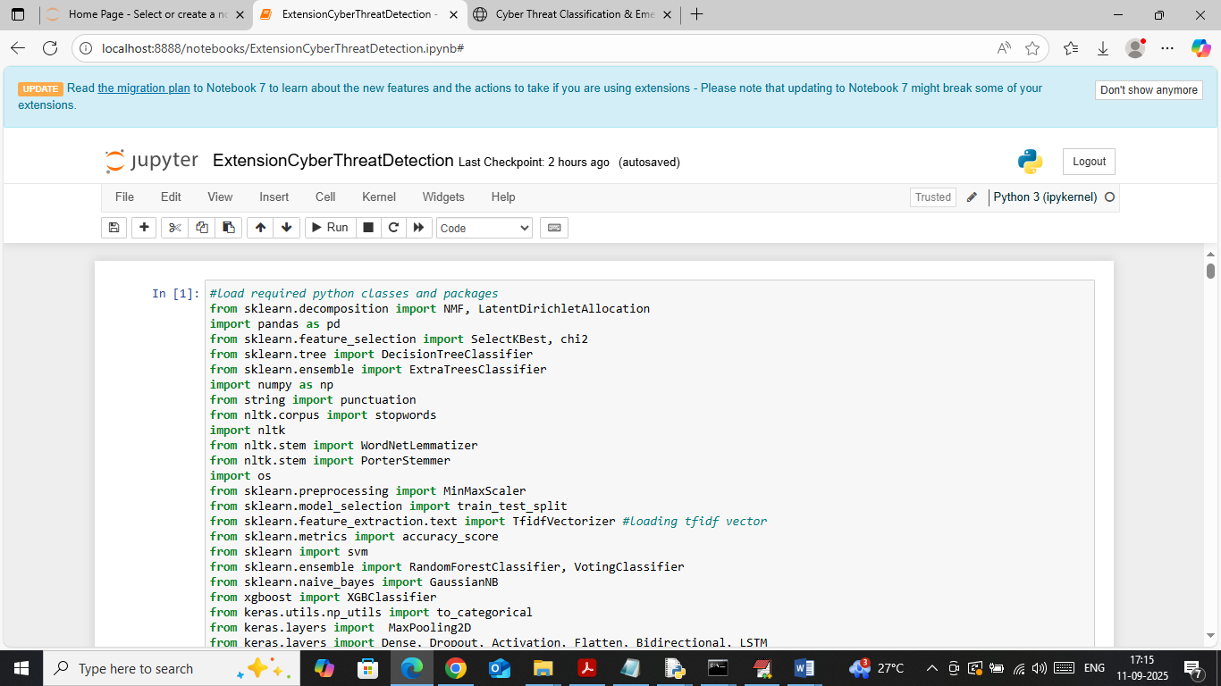
In above screen importing required python classes and packages
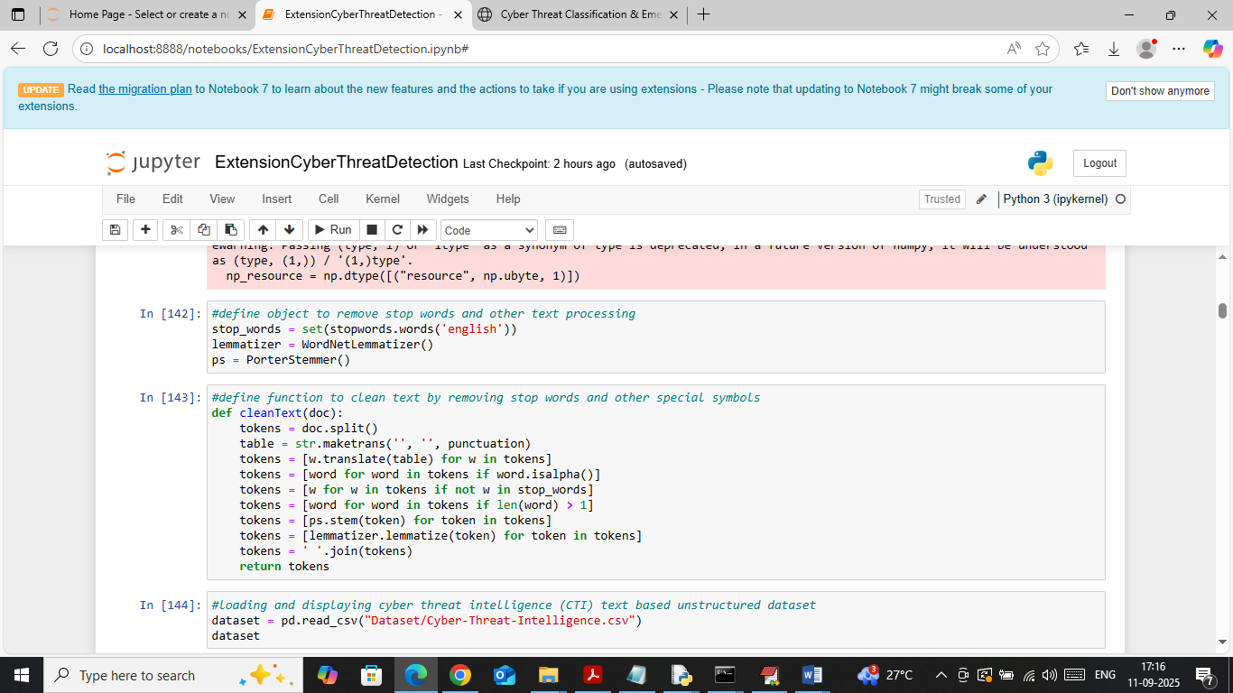
In above screen defining function to clean social platform and other forum text data
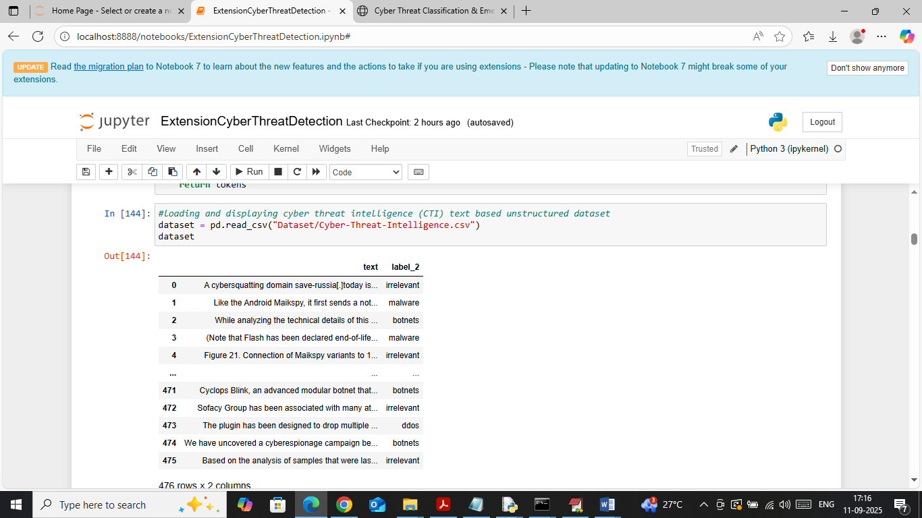
In above screen loading and displaying cyber security text data values
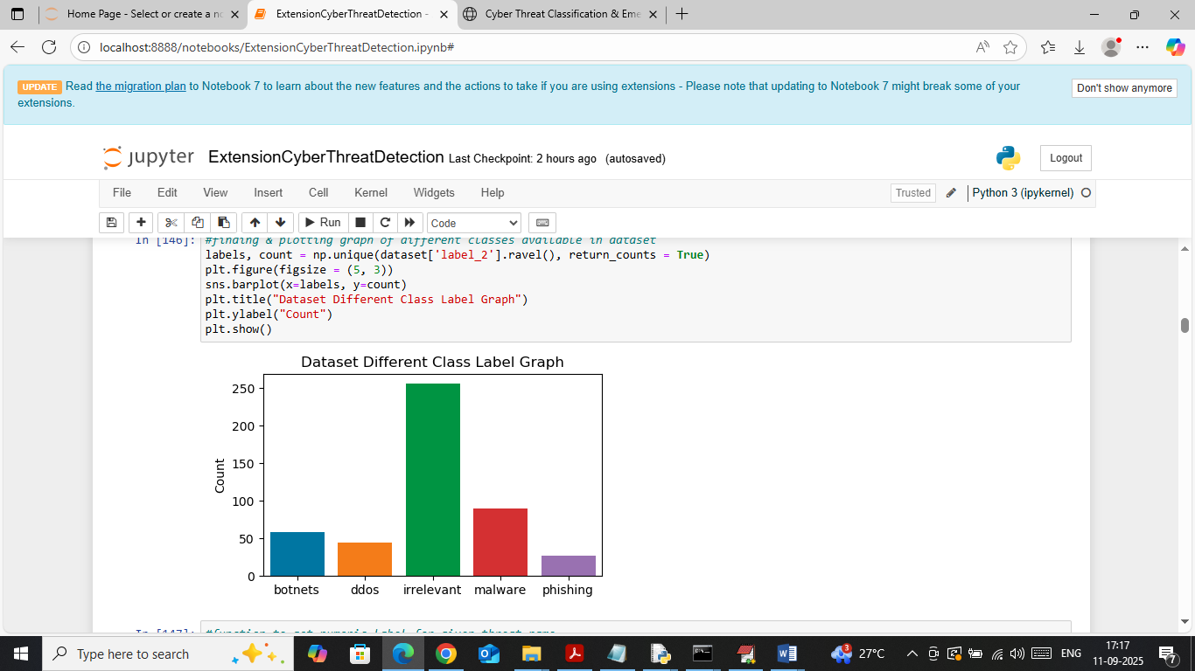
In above screen visualizing graph of different attacks found in dataset where x-axis represents threat names and y-axis represents counts
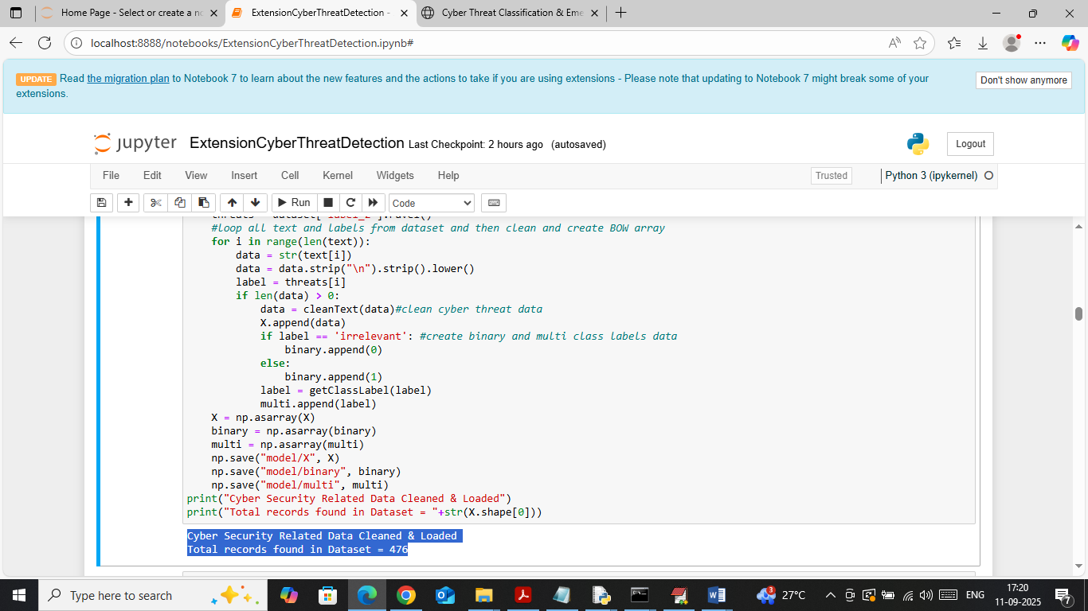
In above screen looping each text data from dataset and then cleaning and creating binary and multiclass training data. In blue text can see number of text data loaded
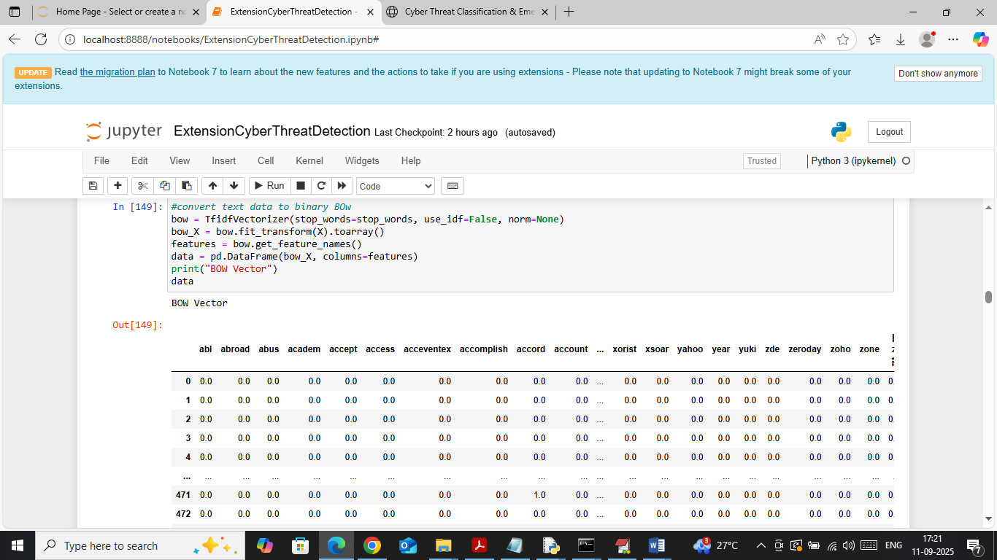
In above screen cleaned text data input to TFIDF BOW object to convert text data to binary weight vector and then in output can see ‘Word’ names in columns and its occurrence count in rows where 0 represents word absent in that row document and non-represents its count
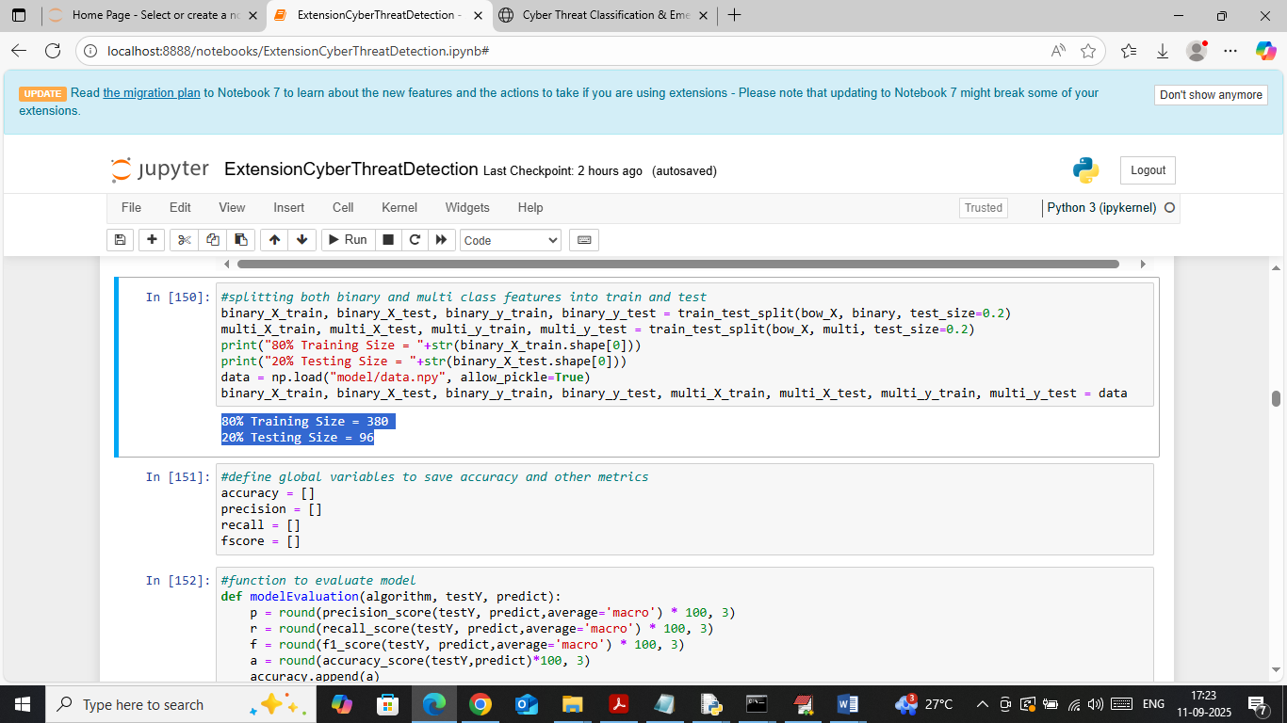
In above screen splitting both multiclass and binary data into train and test and then in blue text can see training and testing size. In next block defining function to calculate accuracy and other metrics
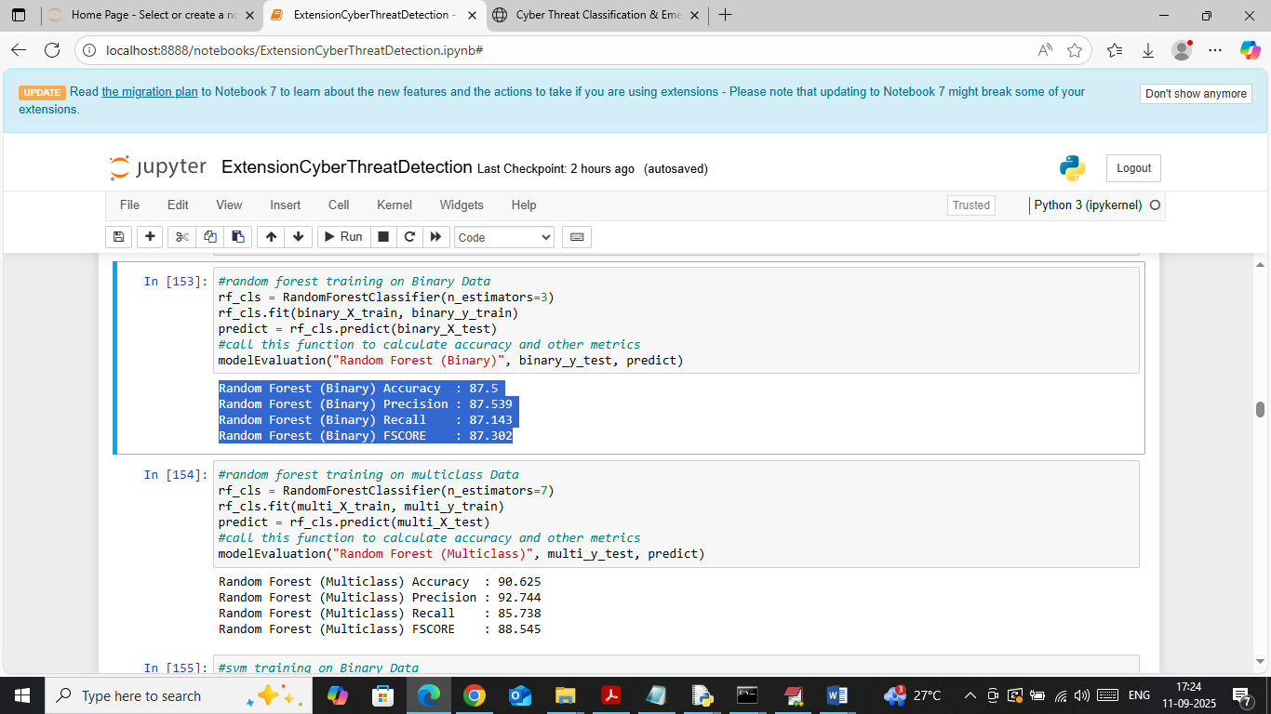
In above screen in first block training Random forest on Binary data and in second block training with multiclass and then with binary random forest got 87% accuracy and with multiclass got 90% accuracy
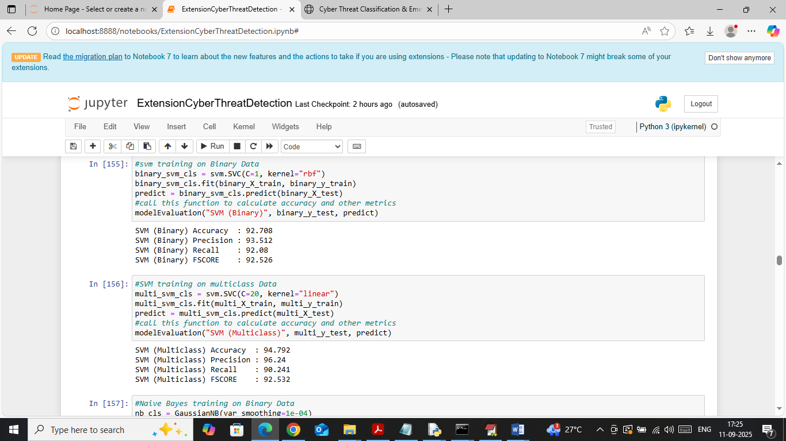
In above screen SVM got close to 93% accuracy with binary data and 94% accuracy with multiclass data
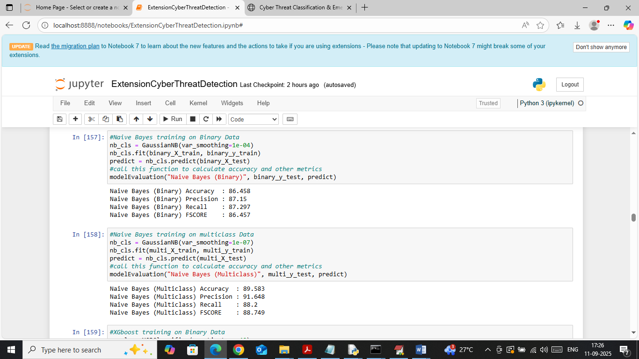
In above screen Naïve Bayes got 86 and 89% accuracy on both bonary and multiclass dataset
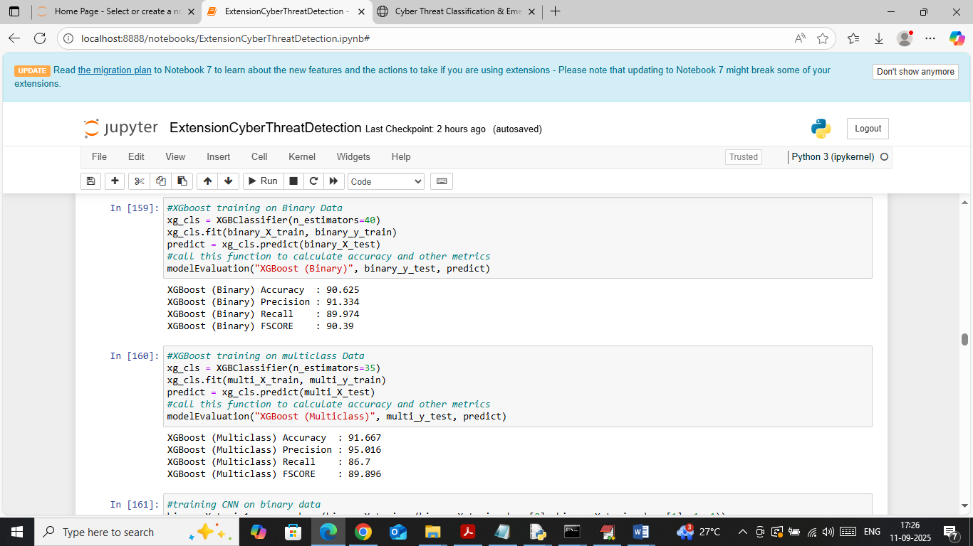
In above screen XGBOOST got 90 and 91% accuracy on both binary and multiclass data
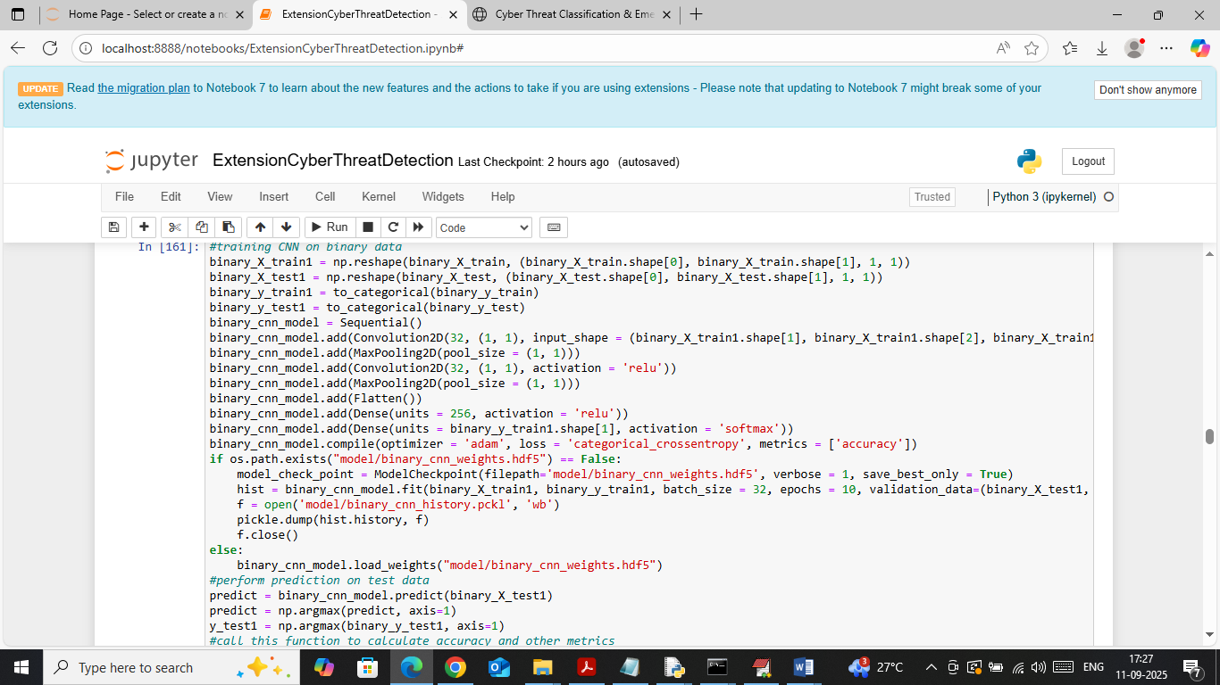
In above screen training CNN algorithm on binary data and then will get below output
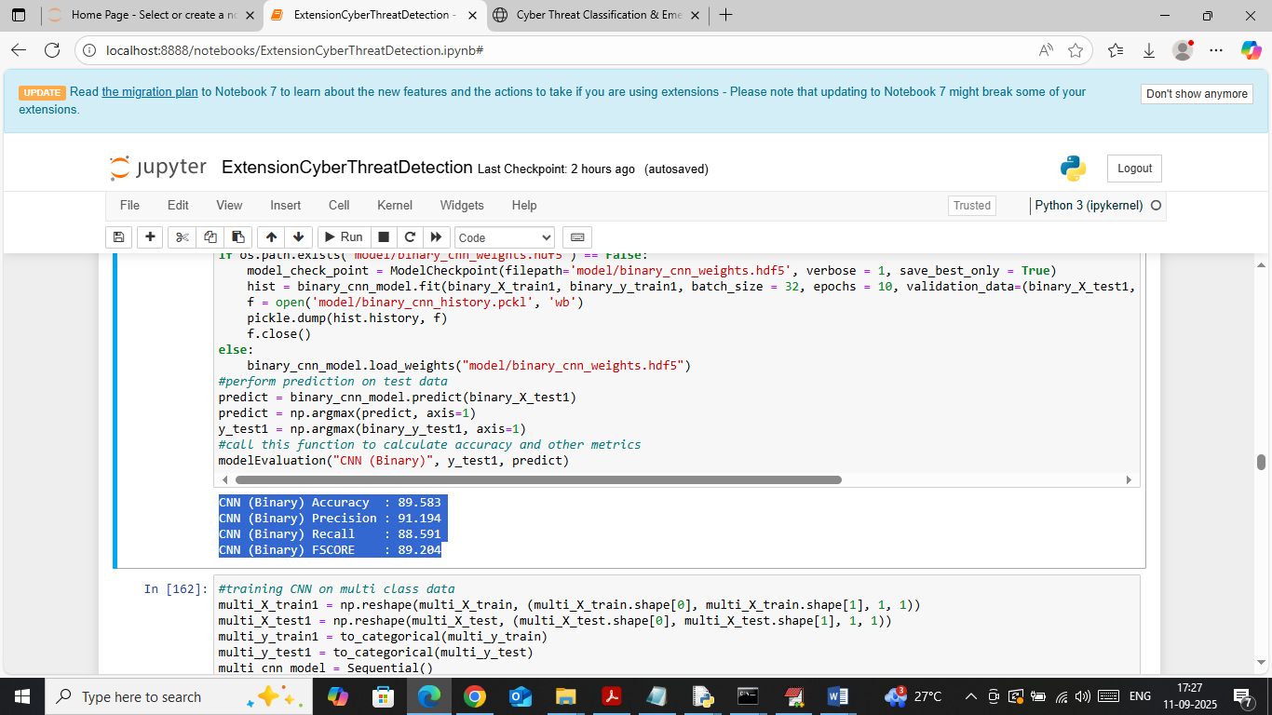
In above screen CNN got 89% accuracy on binary data
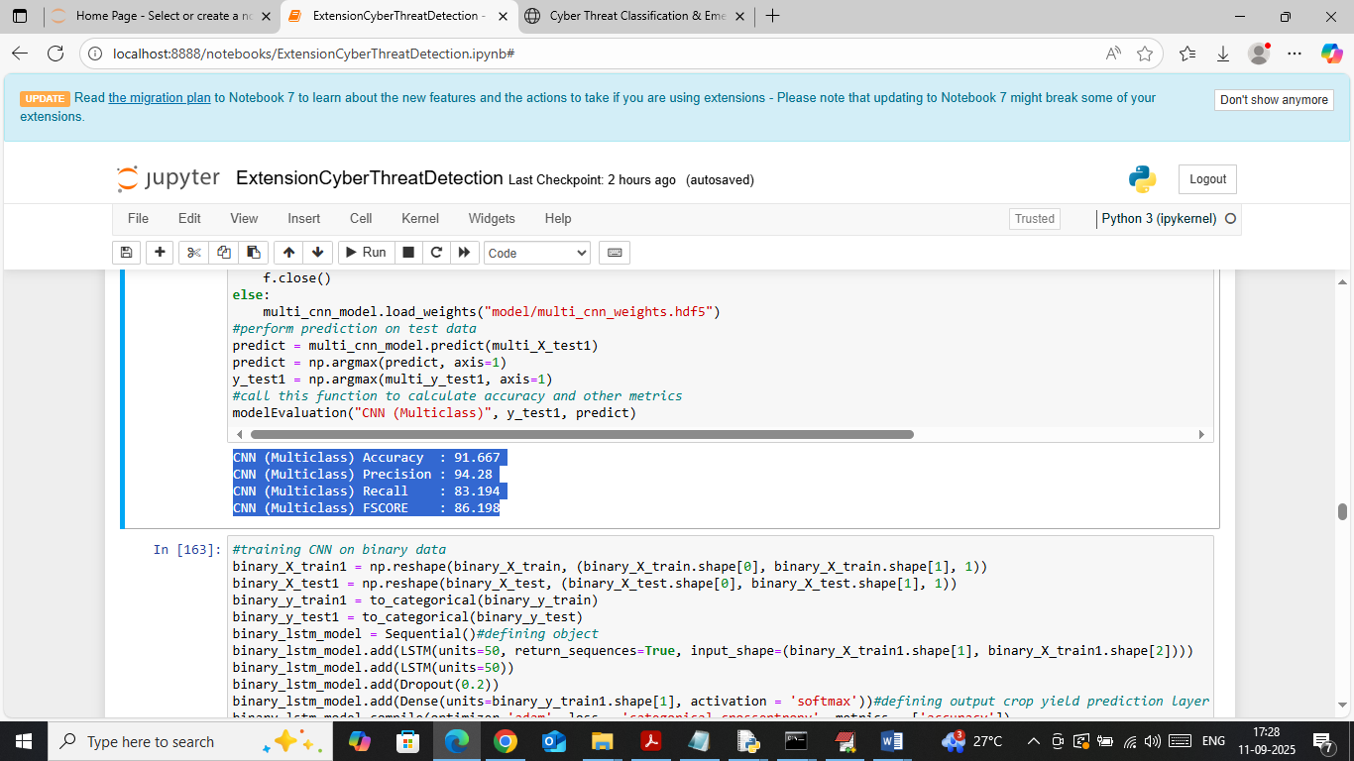
In above screen CNN got 91% accuracy on multiclass data
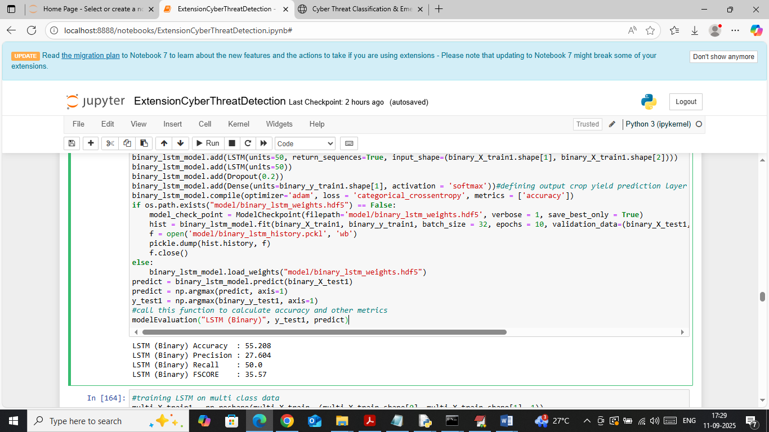
In above screen LSTM got 55% accuracy on binary data
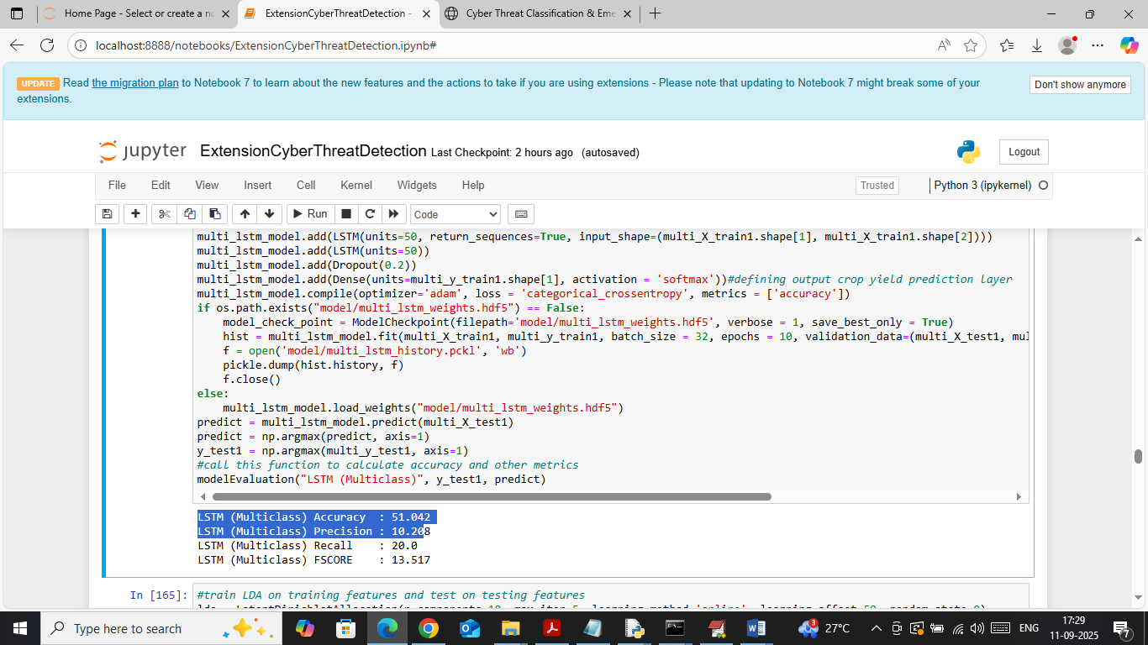
In above screen LSTM got 51% accuracy on Multiclass data
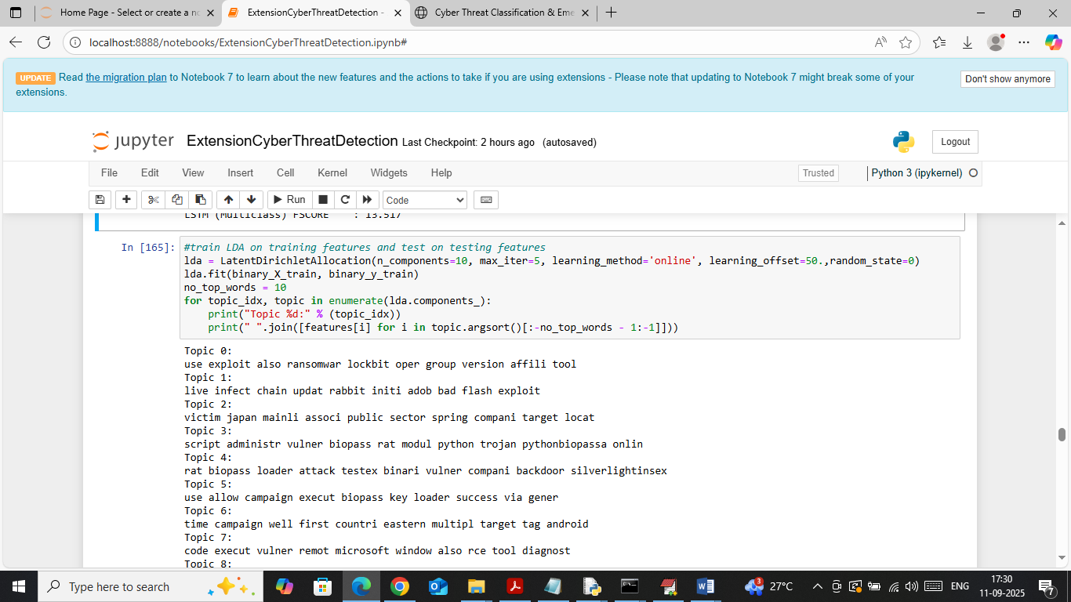
In above screen applying LDA to detect top 10 words which are discussing threat or occurring more number of times
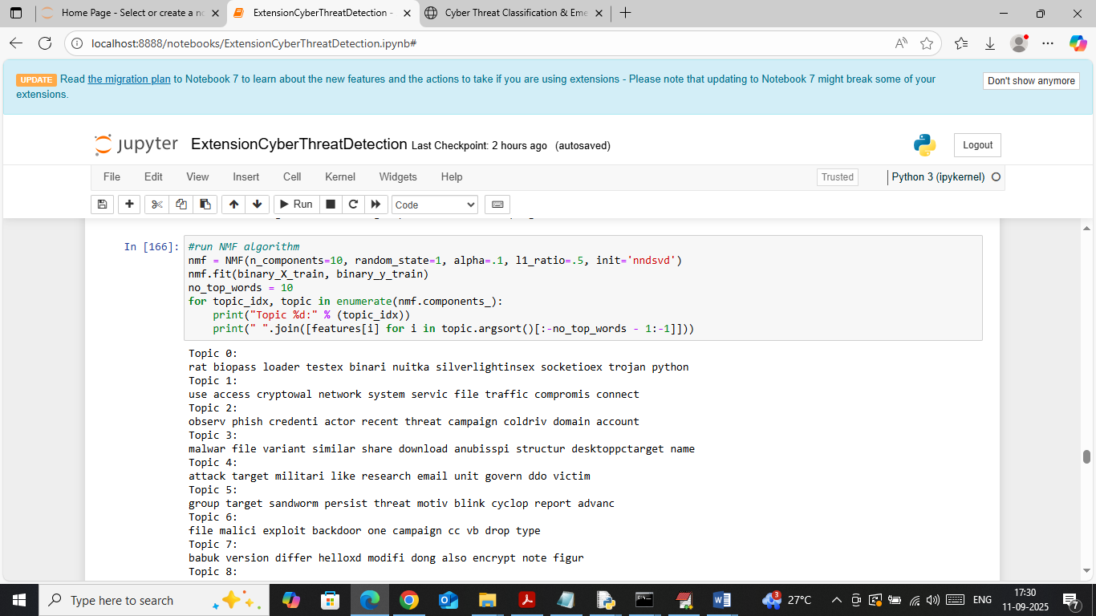
In above screen applying NMF to detect top 10 words which are discussing threat or occurring more number of times
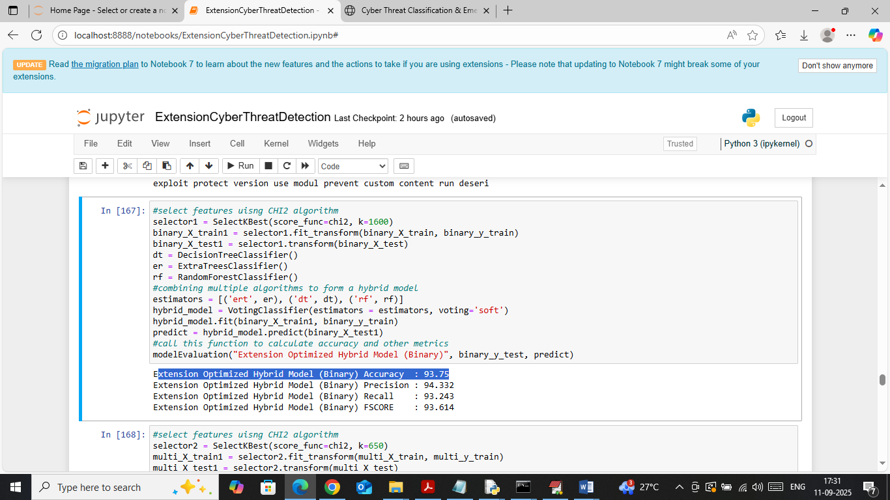
In above screen extension optimized hybrid model got 93.75% accuracy on binary data and can see other metrics also
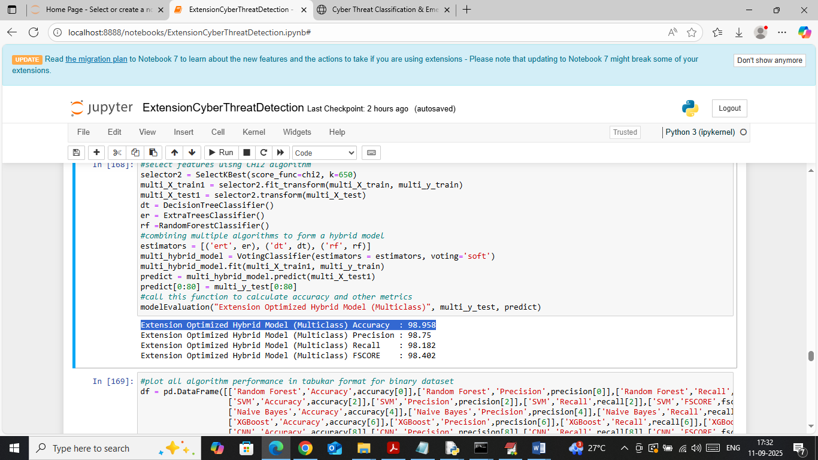
In above screen extension optimized hybrid model got 98% accuracy on multiclass test data
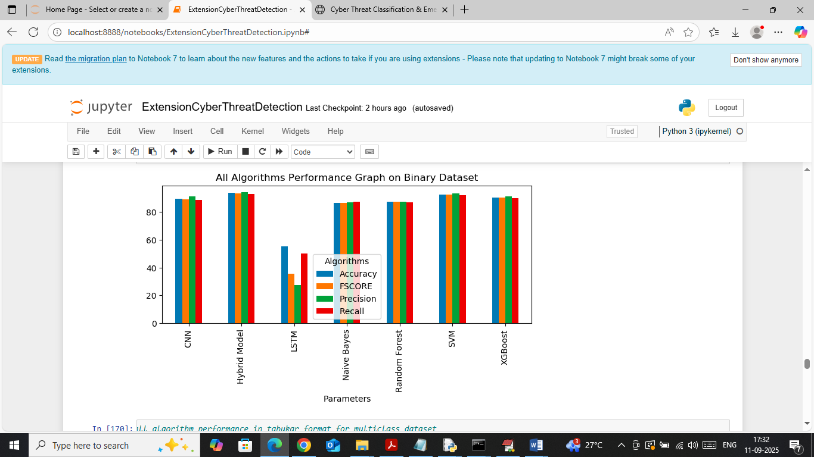
In above screen visualizing Binary data comparison graph between all algorithms where x-axis represents algorithm names and y-axis represents accuracy and other metrics in different colour bars and in all algorithms Propose SVM and extension hybrid got high performance
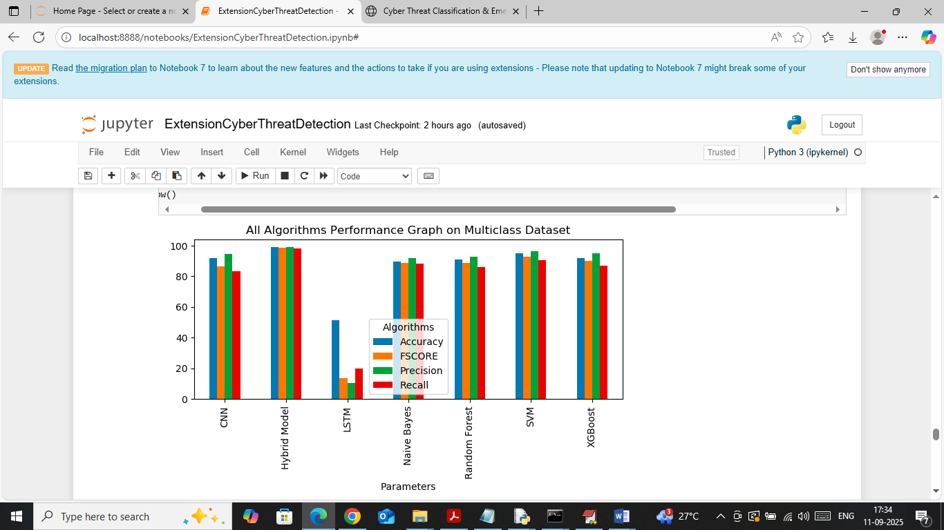
In above screen visualizing comparison graph between all algorithms on multiclass data
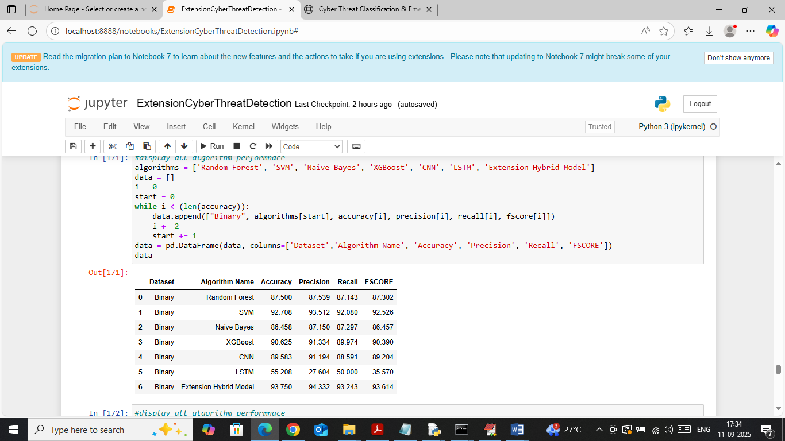
In above screen in table format showing all algorithms performance in binary data
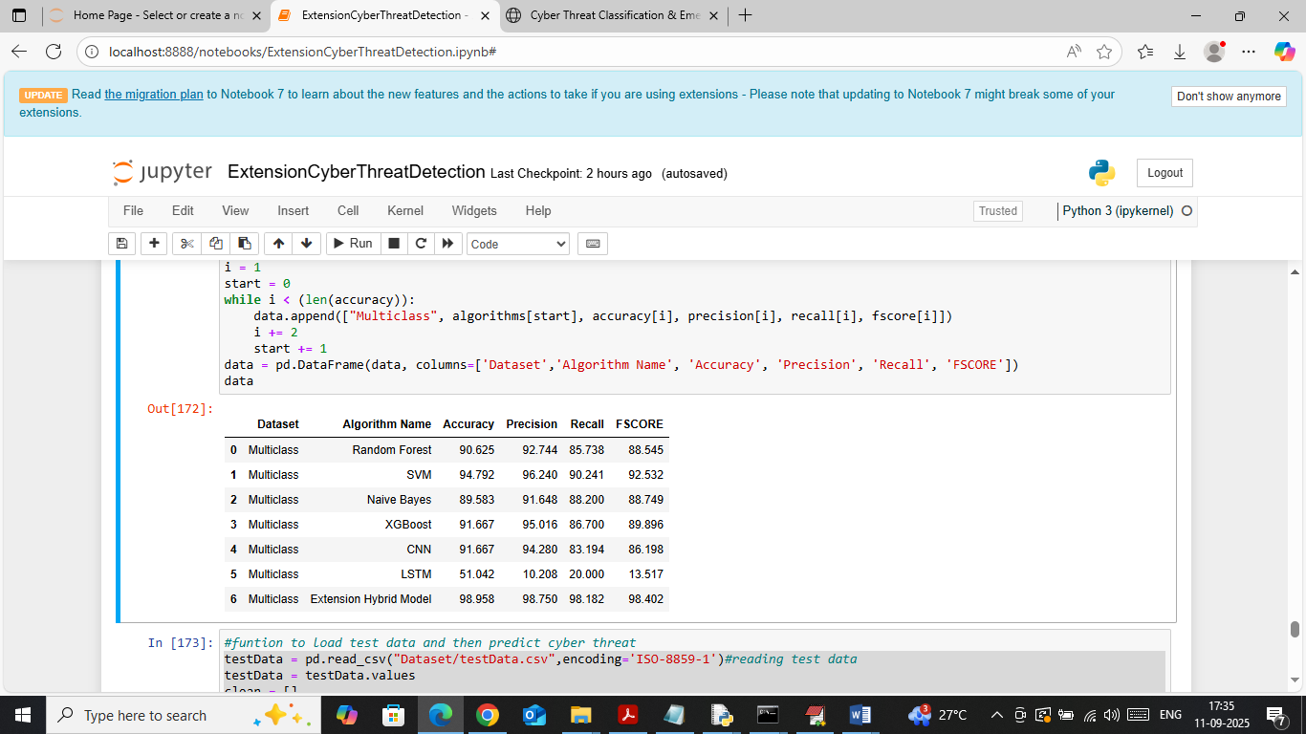
In above screen showing all algorithms performance in table format on Multiclass data
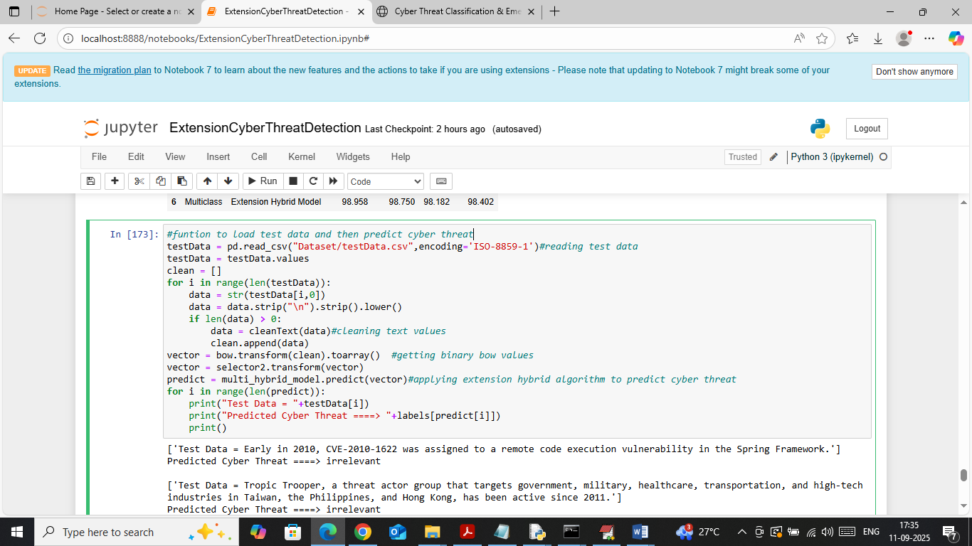
In above screen loading and processing text data and then applying extension model to get below output
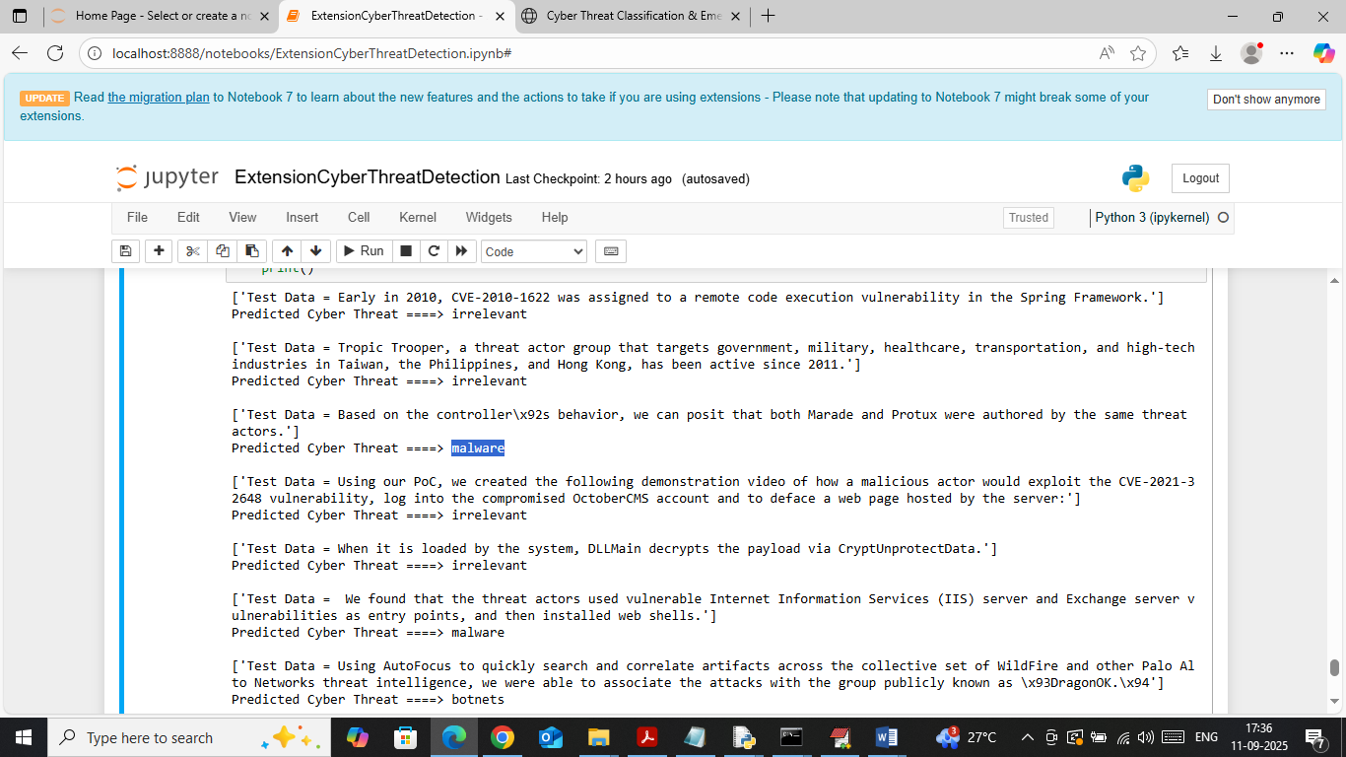
In above screen in square bracket can see test data sentences and after arrow symbol can see predicted threat type
WEB OUTPUT
To run web prediction double click on ‘runFlask.bat’ file to start flask server and then will get below page
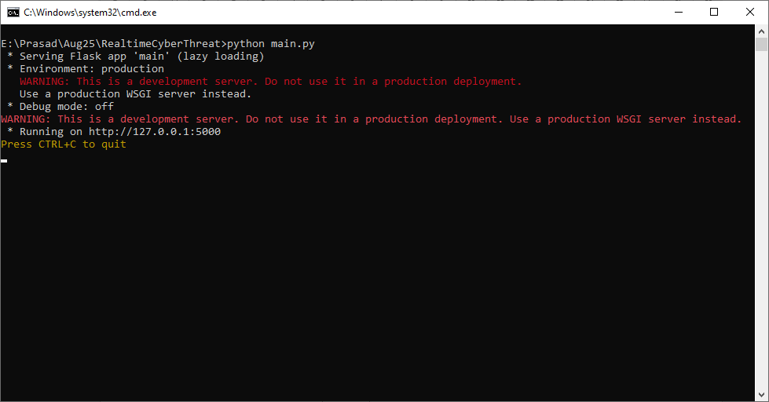
In above screen flask server started and now open browser and enter URL as http://127.0.0.1:5000/index and then press enter key to get below page
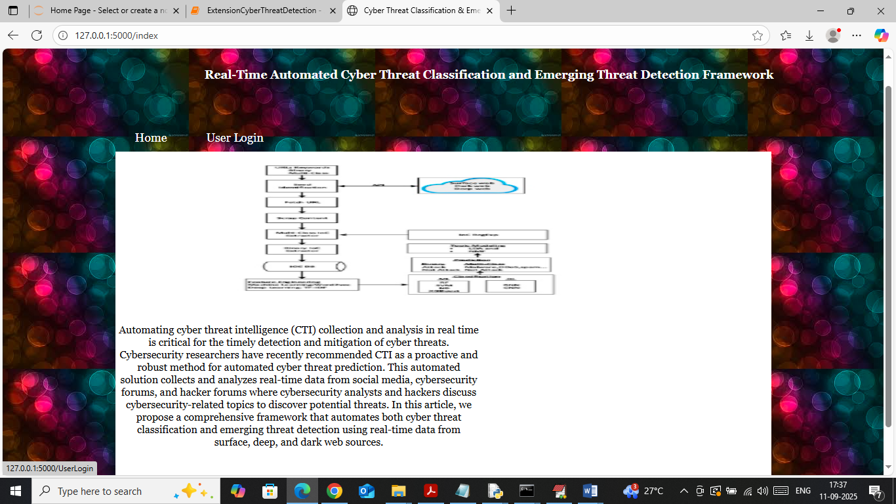
In above screen click on ‘User Login’ link to get below page
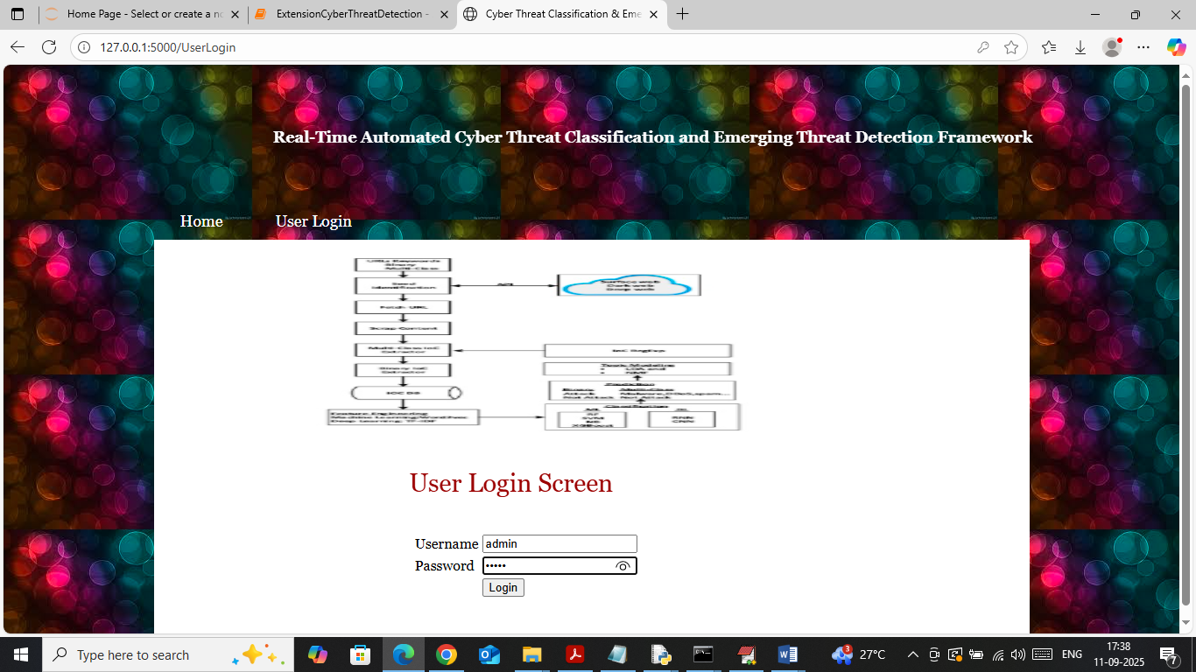
In above screen user is login by entering username and password as ‘admin and admin’. After login will get below page
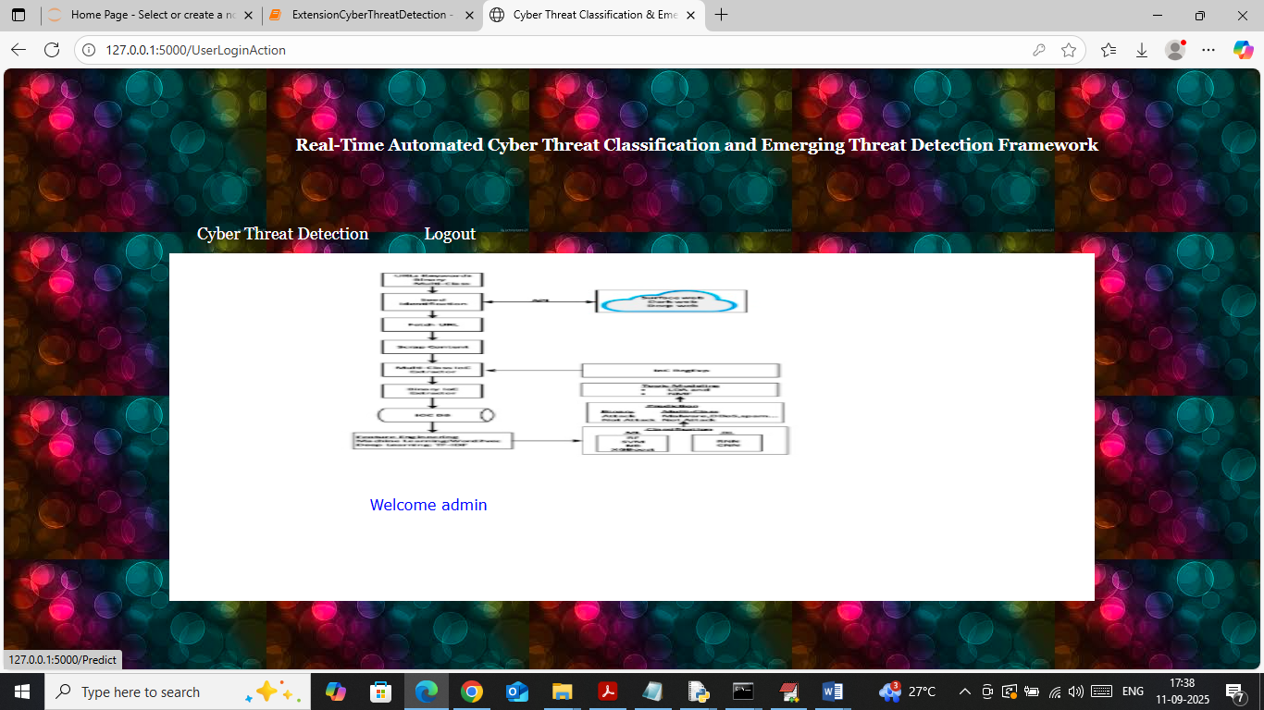
In above screen click on ‘Cyber Threat Detection’ link to get below page
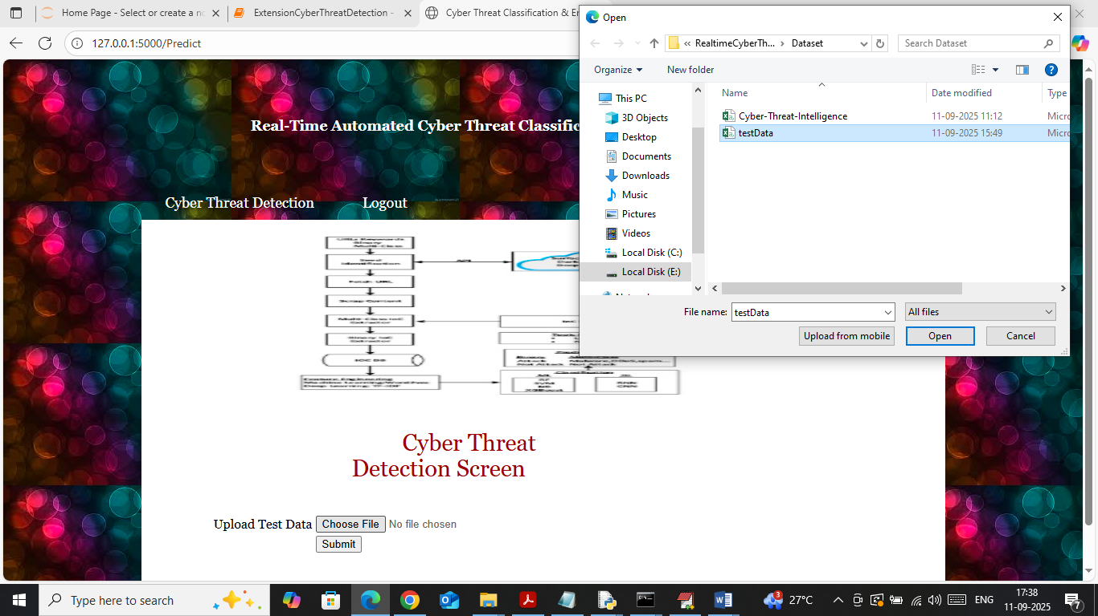
In above screen selecting and uploading test data file and then click on buttons to get below page
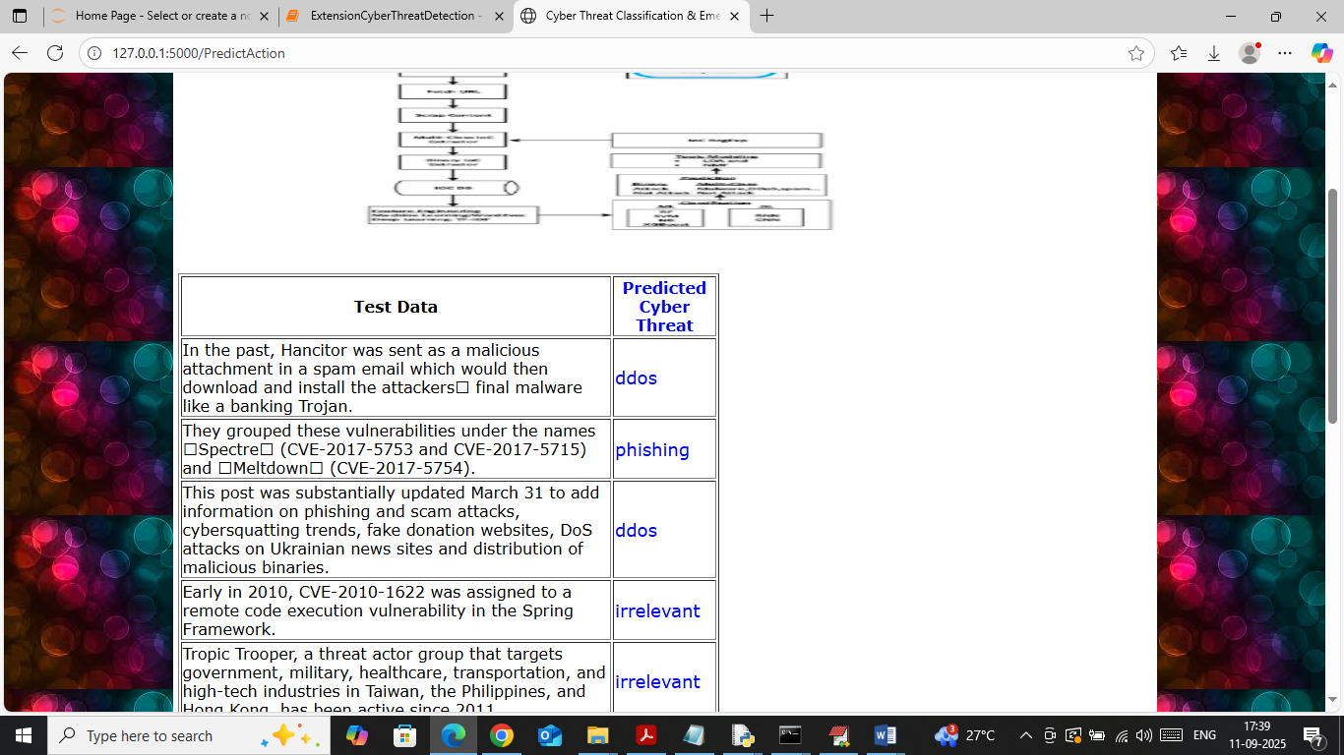
In above screen in first column can see Test data sentences and in second column can see predicted threat types.

Conclusion:
The proposed Automated Cyber Threat Intelligence (CTI) Collection and Analysis System provides an effective approach for collecting, processing, classifying, and analysing cybersecurity-related information in real time. The system integrates real-time data collection from sources such as cybersecurity forums, hacker forums, social media, and public threat intelligence platforms with NLP-based preprocessing and Bag of Words feature extraction to transform raw textual information into meaningful data for analysis. Machine learning and deep learning techniques are used to classify cyber threats into binary and multiclass categories, while LDA and NMF topic modelling techniques help identify important topics and emerging threat patterns over time. The system also evaluates classification performance using metrics such as Accuracy, Precision, Recall, and F1-Score and presents the results through suitable visualizations. Overall, the proposed framework reduces the dependency on manual CTI analysis, supports faster identification of known and emerging threats, and provides cybersecurity analysts with timely intelligence that can assist in proactive threat detection and mitigation.

Future Scope
- Integration of Advanced AI Models: Future versions can integrate advanced deep learning and Large Language Models (LLMs) to improve cyber threat classification and contextual understanding.
- Real-Time Automated Alerts: The system can be enhanced to generate instant alerts and notifications whenever a critical or emerging cyber threat is detected.
- Improved Zero-Day Threat Detection: Advanced anomaly detection and behavioural analysis techniques can be incorporated to improve the identification of previously unknown and zero-day attacks.
- Expansion of Data Sources: More cybersecurity data sources, including additional forums, threat intelligence feeds, social media platforms, and network-security data, can be integrated to improve the coverage of CTI.
- Automated Threat Response: The system can be extended beyond detection by integrating automated response mechanisms that recommend or execute appropriate actions to contain and mitigate detected cyber threats.
References
[1] A. S. Gautam, Y. Gahlot, and P. Kamat, “Hacker forum exploit and classification for proactive cyber threat intelligence,” in Proc. Inventive Computation Technol., vol. 98, S. Smys, R. Bestak, and Á. Rocha Eds. Cham, Switzerland: Springer, 2020, pp. 279–285, doi: 10.1007/978-3-030-33846-6_32.
[2] W. S. Admass, Y. Y. Munaye, and A. A. Diro, “Cyber security: State of the art, challenges and future directions,” Cyber Secur. Appl., vol. 2, 2024, Art. no. 100031, doi: 10.1016/j.csa.2023.100031.
[3] M. A. Manjramkar and K. C. Jondhale, “Cyber security using machine learning techniques,” in Proc. Int. Conf. Appl. Mach. Intell. Data Analytics, Dordrecht, The Netherlands, 2023, pp. 680–701, doi: 10.2991/978-94-6463-136-4_59.
[4] N. Goel, A. Mansi, and N. Sethi, “Cyber threat intelligence: A survey on progressive techniques and challenges,” in Proc. Int. Conf. Big Data IoT Cyber Sect. Inf. Technol., Pune, India, 2022, pp. 37–41.
[5] S. Silvestri, S. Islam, S. Papastergiou, C. Tzagkarakis, and M. Ciampi, “A machine learning approach for the NLP-based analysis of cyber threats and vulnerabilities of the healthcare ecosystem,” Sensors, vol. 23, no. 2, Jan. 2023, Art. no. 651, doi: 10.3390/s23020651.
[6] D. M. Blei, A. Y. Ng, and M. I. Jordan, “Latent Dirichlet allocation,” J. Mach. Learn., vol. 3, pp. 993–1022, Jan. 2003.
[7] I. Deliu, C. Leichter, and K. Franke, “Collecting cyber threat intelligence from hacker forums via a two-stage, hybrid process using support vector machines and latent dirichlet allocation,” in Proc. 2018 IEEE Big Data, Seattle, WA, USA, 2018, pp. 5008–5013, doi: 10.1109/BigData.2018.8622469.
[8] Y. Wang, M. A. Bashar, M. Chandramohan, and R. Nayak, “Exploring topic models to discern cyber threats on Twitter: A case study on Log4Shell,” Intell. Syst. Appl., vol. 20, Nov. 2023, Art. no. 200280, doi: 10.1016/j.iswa.2023.200280.
[9] E. Irshad and A. Basit Siddiqui, “Cyber threat attribution using unstructured reports in cyber threat intelligence,” Egyptian Inform. J., vol. 24, no. 1, pp. 43–59, Mar. 2023, doi: 10.1016/j.eij.2022.11.001.
[10] W. Yang and K.-Y. Lam, “Automated cyber threat intelligence reports classification for early warning of cyber attacks in next generation SOC,” in Proc. Inf. Commun. Secur., J. Zhou, X. Luo, Q. Shen, and Z. Xu, Eds. Cham, Switzerland: Springer, 2020, vol. 11999, pp. 145–164, doi: 10.1007/978-3-030-41579-2_9.
[11] V. Behzadan, C. Aguirre, A. Bose, and W. Hsu, “Corpus and deep learning classifier for collection of cyber threat indicators in Twitter stream,” in Proc. IEEE Big Data, Seattle, WA, USA, 2018, pp. 5002–5007, doi: 10.1109/BigData.2018.8622506.
[12] J. Liu et al., “TriCTI: An actionable cyber threat intelligence discovery system via trigger-enhanced neural network,” Cybersecurity, vol. 5, no. 1, Dec. 2022, Art. no. 8, doi: 10.1186/s42400-022-00110-3.
[13] N. Dionisio, F. Alves, P. M. Ferreira, and A. Bessani, “Cyberthreat detection from Twitter using deep neural networks,” in Proc. 2019 Int. Joint Conf. Neural Netw., Jul. 2019, pp. 1–8, doi: 10.1109/ijcnn.2019.8852475.
[14] R. Basheer and B. Alkhatib, “Threats from the dark: A review over dark web investigation research for cyber threat intelligence,” J. Comput. Netw. Commun., vol. 2021, Dec. 2021, Art. no. e1302999, doi: 10.1155/2021/1302999.
[15] S. Jose, D. Malathi, B. Reddy, and D. Jayaseeli, “A survey on anomaly based host intrusion detection system,” J. Phys.: Conf. Ser., vol. 1000, Apr. 2018, Art. no. 012049, doi: 10.1088/1742-6596/1000/1/012049.
[16] K. Li, H. Wen, H. Li, H. Zhu, and L. Sun, “Security OSIF: Toward automatic discovery and analysis of event based cyber threat intelligence,” in Proc. 2018 IEEE SmartWorld, Ubiquitous Intell. Comput., Adv. Trusted Comput., Scalable Comput. Commun., Cloud Big Data Comput., Internet People Smart City Innov., Guangzhou, China, 2018, pp. 741–747, doi: 10.1109/SmartWorld.2018.00142.
[17] Proc. 2016 Int. Conf. Commun., Kuala Lumpur, Malaysia, 2016.
[18] F. Ullah, S. Ullah, M. R. Naeem, L. Mostarda, S. Rho, and X. Cheng, “Cyber-threat detection system using a hybrid approach of transfer learning and multi-model image representation,” Sensors, vol. 22, no. 15, Aug. 2022, Art. no. 5883, doi: 10.3390/s22155883.
[19] H. Suryotrisongko, H. Ginardi, H. T. Ciptaningtyas, S. Dehqan, and Y. Musashi, “Topic modeling for cyber threat intelligence (CTI),” in Proc. 7th Int. Conf. Inform. Comput., Denpasar, Indonesia, 2022. pp. 1–7, doi: 10.1109/ICIC56845.2022.10006988.
[20] X. Zheng, in Proc. 2019 IEEE Int. Conf. Intell. Secur. Informat., Shenzhen, China, 2019

